Windows on the World:

PUBLIC EXHIBITS IN
THE MUSEUM OF NATURAL SCIENCE AT LOUISIANA STATE UNIVERSITY

A SEMICENTENNIAL TRIBUTE

1936 - 1986

Peter A. Soderbergh

WINDOWS ON THE WORLD:
PUBLIC EXHIBITS IN THE MUSEUM OF NATURAL SCIENCE AT LOUISIANA STATE UNIVERSITY

A SEMICENTENNIAL TRIBUTE
1936 - 1986

Peter A. Soderbergh

Copyright 1986
Patrons of the Louisiana State University Museum of Natural Science

All Rights Reserved

Library of Congress Catalogue Number: 86-27245 ISBN 0-9617661-0-7

Photographs by Jim Zeitz and Prather Warren of LSU's Office of Public Relations

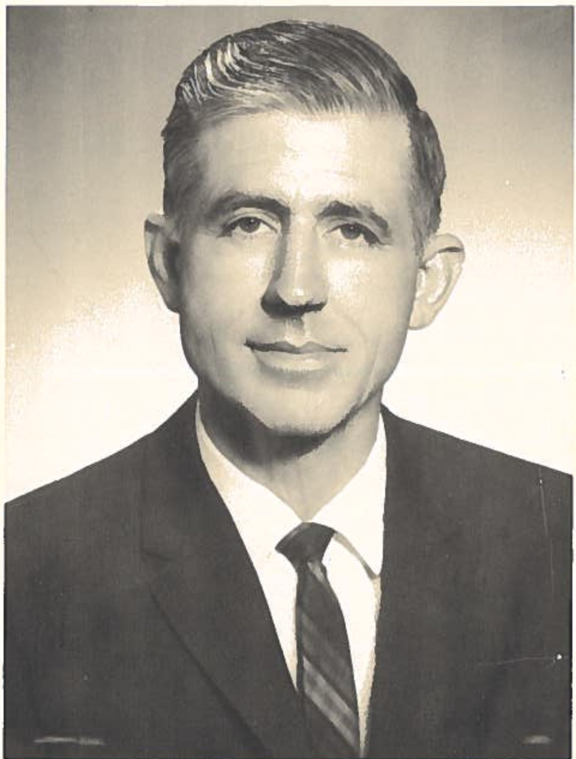

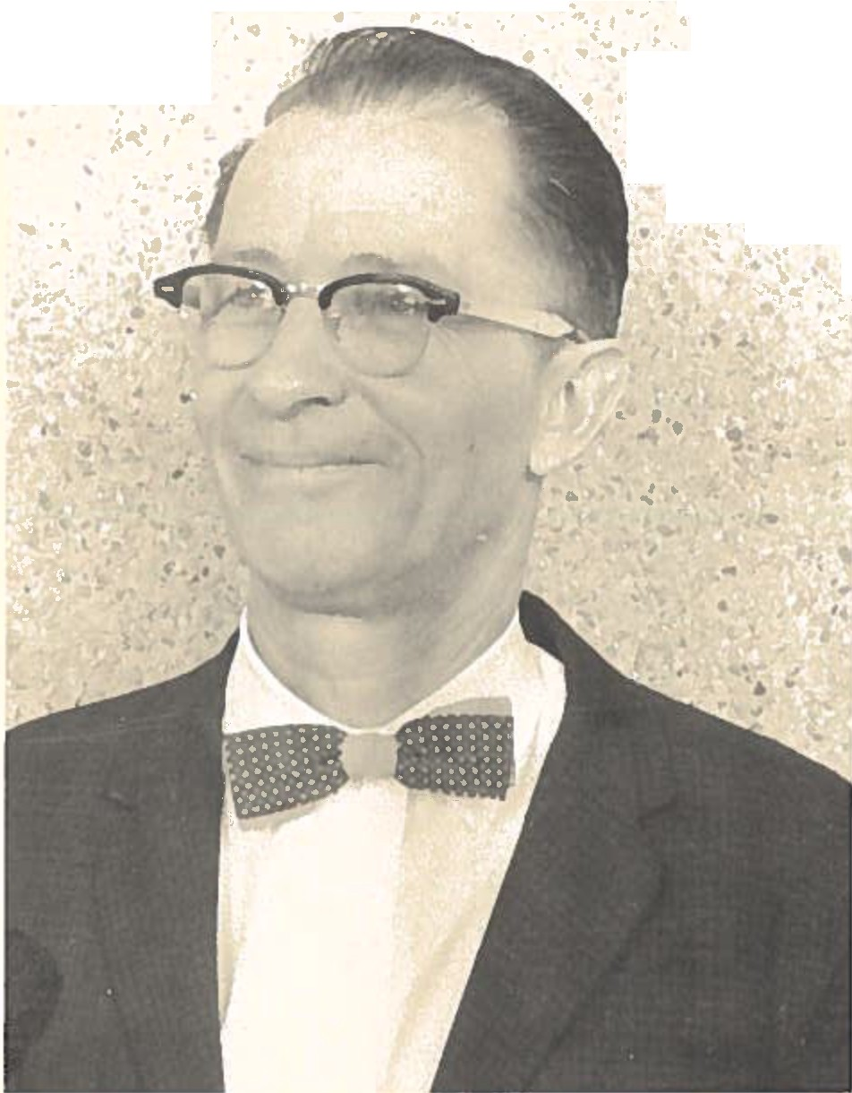George Lowery and Ambrose Daigre during the period in which the public exhibits were constructed (1952-64)
..
·•
• .t.'""'", - •)i J..
,: .....
; ' .,,,..,·/ ' .
... ..: .. ,
,,"-.,;

:t,. "'. • ..
;.., .... :.::,· .,)
t .: ·,'..
- ' ,ii,
,,.

DEDICATION

To the memory of George Hines Lowery, Jr. (1913-1978), scholar, visionary, founder
and
Director of Louisiana State University's Museum of Natural Science.
and to
P. Ambrose Daigre, the master craftsman whose artistry immeasurably advanced the cause of museumship at LSU.

I

TABLE OF CONTENTS
Acknowledgements i
Chronology (1910-86) xi
Prologue:
The Rise of George H. Lowery, Jr. 1
Part One:
P. Ambrose Daigre and the "Dream Plan" 39
Part Two: Windows on the World 77
Part Three: Toward a New Millenium 145
About the Author 167

ACKNOWLEDGMENTS

In 1985 the Executive Committee of the Patrons Association of LSU's Museum of Natural Science decided that. ways should be found to commemorate the Golden Anniversary of the founding of the Museum in 1936. Talk turned to the possibility of underwriting a monograph in which the Museum's first half-century would be described. Since neither a comprehensive recounting of the evolution of the Museum's total character nor full-length biographies of Dr. George H. Lowery, Jr. and P. Ambrose Daigre fell within the purview (or resources) of the Association, the Committee felt that it should restrict the focus of its proposed study to the public exhibits and how they came to be the magnificent displays they are.
Twenty-two years have passed since the last of the
nine habitat groups, "The Great Southwestern Desert", wqs completed. With that final touch three decades of plan­ ning and ten years of hard labor came to a fitting end. The Executive Committee believed that displays which had

brought so much pleasure and illumination to so many visi­ tors deserved recognition. It is likely that in excess of 900,000 children and adults have come to Murphy J. Foster Hall to look at, and learn from, the unique exhibits since March, 1955. Citizens who were brought to the Museum when they were little have returned -- with their own children in tow -- to relive their original feelings of amazement. Several generations of Louisianians have strolled by the wildlife panoramas, pushed the buttons that activate recorded explanations of what they were seeing, and stared in wonder at glass-enclosed specimens from the physical world -- and still they come by the thousands every year. In 1967 the late Lowell Thomas, writing in Popular Science Magazine, published a guide to the nation's 125 "outstand­ ing attractions." LSU's Museum of Natural Science was the only one of the "fascinating places for... readers to visit" located within the borders of the State. There is every reason to believe people will continue to find the Museum "fascinating" in 1987 and beyond.
Visitors depart Foster Hall informed and exhilarated, as a rule. It is doubtful, however, that they appreciate to what extent George Lowery and Ambrose Daigre, and others,

provided the inspiration and the energy it took to give birth to the exhibits. How could they? Until now there was nothing to put in their hands that would tell that story. The Patrons Association thought it should be told, briefly and accurately, not only as a tribute to Lowery and Daigre but as a means of communicating to its constituents, and the general public, what a prized possession lies in their midst. In 1960 a reporter from the Shreveport Times was awestruck by what she encountered in Foster Hall's west wing. "The dioramas," she wrote, "are the real jewels of the museum." True enough, then and now. It could be said also that the entire Museum -- research collections and public exhibits -- is a jewel in LSU's crown on which no material value can be placed.
I am privileged to be the instrument through which this singular aspect of the Museum's distinguished history may be made known to a wider audience. Were it not for C. Fenton Rutledge, the Patrons Association's first President (1984-86), his successor Ms. Janie Braud, and their dedicated colleagues on the Association's Executive Committee, this modest chronicle might never have been written. They placed considerable faith in my judgment,

granted me absolute literary freedom, and supplied constructive criticisms of an early draft of this manuscript. It is a pleasure to be indebted to men and women of unquestioned integrity.
Had I been restricted to employing written sources exclusively, I could not have prepared a text as rich as I hope this proves to be to those who read it. I desperately needed the sort of data which one might describe as "living testimonials" from persons present at the creation, and I was rewarded many times over. Among those who were forth­ coming with their comments I am ob1 i ged to acknowledge first certain members of Lowery's and Daigre's families. They never told me less than I wanted to know. They told me things I was not wise enough to ask about. They shared with me whatever memories and documents were at their disposal, responded graciously to my often untimely inquiries, and urged me not to falter in my mission. I refer in partic­ ular to Ms. Jeanette Lowery Watson of Baton Rouge and Ms. Carol Lynn Lowery Loker of Beaumont, Texas, George and Jean Lowery's daughters. The love they feel for their deceased parents acted upon me as a safeguard when I was inter­ preting events that happened before I came to LSU. I

should not forget to say that their mother's sister, Ms. Evelyn T. Benton of Baton Rouge, contributed vignettes about the Lowery family during World War II that I found extremely usefu1. Another person whose assistance was of inestimable worth is Ambrose Daigre's sister, Ms. Helen D. Tangney of Baton Rouge. She was very generous with clippings, books, and anecdotes -- and her valuable time -­ throughout the year in which I researched this subject. I can say truthfully that a serious imbalance would exist in my text had she not been willing to supplement her brother's recollections with remembrances of her own. Additional insights into Daigre's early years and formal education were provided by Mr. Camille F. Gravel, Jr., of Alexandria, and Msgr. Julius J. Walle, Chancellor of the Diocese of Alexandria.
I learned much about Lowery and Daigre from delightful people who were active at LSU during the halcyon days of museum-building. Foremost among them I count Chancellor Emeritus Cecil G. Taylor and Dr. Robert J. Newman, both of Baton Rouge. Taylor Is perspectives on the development of the Museum from an administrator's viewpoint were very helpful. Newman, whose role in the advancement of museum-

ship at LSU has long been undervalued, was Lowery's close associate from 1945 to 1976. He shared his opinions with me freely. Dr. Wayne P. Wallace of Lafayette, formerly a faculty member in LSU's Civil Engineering department, spoke to me about his (and the late Dr. Ollie 110.J.11 Baker's) involvement in the structural organization of the dioramic 11domes11• From Ms. El eanor V. Roberts, wife of Zoology professor J. Harvey Roberts of Baton Rouge, I received important information concerning Lowery in the late 19301s. If I did not express my sincere appreciation to each of the aforementioned individuals I would be guilty of what Lowery called "reprehensible ingratitude". A special nod in the direction of Mr. John J. Morony, Jr. of Jennings is called for. Morony took his Master's degree under Lowery, served as a Curatorial Associate at the Museum (1968-72), and was the catalyst behind the formation of the Patrons Associa­ tion. My discussions with him have been enlightening always.
A large measure of what I discovered about the Museum was gleaned from talks with its faculty and staff. Every­ one in Foster Hall was interested in this project, but I must take note of the indispensable contributions of: Dr.

Douglas A. Rossman, Director of the Museum (1984-86) and reader of the first version of this monograph; Dr. John P. O'Neill, Coordinator of Field Studies and Artist-in­ Residence; and Dr. J. Michael Fitzsimons, Curator of Fishes. Each of them responded with enthusiasm to my requests for interviews and allowed me to return for clari­ fications as often as I wished. Th y also gave me access to contemporary documents and inactive files, from which I extracted a wealth of pertinent data. Without the indul­ gence of Ms. Alice J. Fogg, the Museum's devoted secretary, I might have been in serious trouble. She was Lowery Is secretary from 1959 to 1968. Fortunately for all concerned Ms. Fogg returned to the front office in November, 1984. I am genuinely thankful for her cheerful responses to my innumerable requests for information.
From the ranks of the volunteers who worked with Ambrose Daigre on the dioramas, three women stepped forward to offer their recollections: Ms. Barbara M. Bodman, Ms. Imo N. Brown, and Ms. Winifred A. Winfree, all of Baton Rouge. They brought a degree of life to their labors that I could not have recaptured otherwise and I am indebted to

them for explaining the techniques in vogue at the time (1954-60). Appreciations are due also to Ms. Bernell M. Cade and Ms. Sharon K. Beauregard of the LSU System President's office, Ms. Sandy L. Hubbert of LSU's Division of University Relations and Development, and Ms. Mary M. Burnett and Ms. Maxine H. Reddoch, both of whom served in the capacity of secretary to George Lowery.
Mr. Albert L. Clary, Executive Assistant to the Vice­ Chancellor for Academic Affairs at LSU, gave me the benefit of his knowledge of the University's progress since 1946 and acted as a sounding board for my evolving hypotheses, which I appreciate very much. Ms. Vivian H. Alexander dutifully and efficiently typed the original draft of this manuscript, a tedious task she managed to incorporate into her multiple responsibilities, and I thank her profusely for that.
And to my wife Kathy and our children I offer my heartfelt gratitude for their sufferance and support. They endured my need to concentrate without complaint, which I chose to view as evidence of their love for me. I return

that emotion unconditionally. I also assume full responsi­ bility for a11 judgments and interpretations rendered in this text.

Peter A. Soderbergh Baton Rouge, La.
September 15, 1986

CHRONOLOGY (1910-86)

Welcome to a monument that earns the affection and awe of curious people in every walk of life because it entertains and educates as well. Welcome to the temple of earth's physical, bio­ logical and human experience...Welcome to a sanctuary where relics of all earth's past, as all the sciences slowly discover them, safely stay for the eventual edification of mankind.
Philip Kopper (1982)

CHRONOLOGY

September 2, 1910

October 2, 1913

June 4, 1934
 |  |  | o1ogy from LSU.
June | 1, | 1936 | Lowery is awarded the M.S. in Zoology from LSU.
July | 1, | 1936 | Lowery is appointed to LSU fac­

P. Ambrose Daigre is born in Alexandria, Louisiana.

George H. Lowery, Jr. is born in Monroe, Louisiana.

Lowery receives the B.S. in Zo­

ulty as Instructor in Zoology and Assistant Curator of the Museum of Zoology.

March 12, 1937

Muriel E. Tiebout and George H. Lowery, Jr. marry in Baton Rouge.

September 14, 1937

January 18, 1939

July 1, 1945

December 6, 1947

June 6, 1949

August 8, 1949

November 1-7, 1950

June 29, 1951
Daigre enters LSU as a first­ year student.

Lowery promoted to Assistant Professor of Zoology and Curator of the Museum of Zoology.

Lowery promoted to Associate Professor of Zoology.

Louisiana Ornithological Society is organized in New Orleans. Lowery is elected Vice-Presi­ dent.

Lowery receives Ph.D. in Zoology from the University of Kansas at Lawrence.

Naturalist Edward A. Mcilhenny dies at age seventy-seven on Avery Island.

Museum of Zoology moves to Mur­ phy J. Foster Hall.

University of Kansas Museum of Natural History publishes Low­ ery's dissertation.

April 17, 1952

July 1, 1952

July 1, 1953

March 27, 1955

August 3, 1955

November 2, 1955

March 27, 1956

January 9, 1959
Lowery appointed Director of LSU's Museum of Natural Science (MNS}.

Daigre appointed Curator of Ex­ hibits at LSU-MNS.

Lowery promoted to Professor of Zoology.

LSU-MNS opens its doors to the public.

Lowery is elevated to Boyd Professorship by LSU Board of Supervisors.

Lowery is inducted into LSU cir­ cle of Omicron Delta Kappa.

LSU-MNS celebrates its first birthday.

Mastodon remains discovered on Tunica Bayou in West Feliciana Parish.

September 1, 1972

August 30, 1973

January 19, 1978

January 23, 1978

August 12, 1980

January 28, 1981

April 22-23, 1981
Daigre retires after twenty years of service at LSU.

AAM accreditation team reports on status of LSU-MNS.

Lowery dies at 5:00 A.M. at age sixty-four.

George H. Lowery, Jr. Memori a1 Fund For Research and Publ ica­ tion in Vertebrate Zoology es­ tablished through LSU Founda­ tion.

Organizational meeting of the Provisional Council in Support of the MNS in Peabody Hall. Council is forerunner of the LSU-MNS Board of Fellows.

Provisional Council submits "The LSU Museum of Natural Science: A White Paper" to MNS Director.

Dr. Craig C. Black visits mus­ eums at LSU. Black is President of the AAM and Di rector of the Carnegie Museum of Natural His­ tory.

May 1, 1981 Dr. Black's report recommends that LSU give its museums "clear and strong support" and suggests centralization of collections and facilities.

May 19, 1981 First meeting of charter members of LSU-MNS Board of Fellows.

September 10, 1981

October 9, 1981

August 10, 1982

December 22, 1982

February 12, 1983

Constitution and by-laws of Patrons Association and Board of Fellows approved by LSU System President Martin D. Woodin.

Transfer of MNS from Arts and Sciences to Office of Vice-Chan­ cellor for Research approved by President Woodin, to be effec­ tive July 1, 1982.

LSU-MNS curators submit compre­ hensive document on "Space Problems and Plans For the Mus­ eum of Natural Science" to Vice-Chance11or for Research.

Director of MNS announces clos­ ing of public exhibits until further notice.

Jean Lowery dies of cancer at age seventy-one.

February 16, 1984

September 18, 1984

November 29, 1984

April 13, 1985

July 16, 1985

January 31, 1986

September 9, 1986
MNS public exhibits reopen on a limited schedule of sixteen hours per week.

Organizational meeting of LSU­ MNS Patrons Association at Foster Ha11.

First meeting of the Patrons Association Is Executive Commit­ tee.

Docents staff exhibit hall on Saturday for the first time.

Ambrose Daigre is guest of Patrons Association, discusses preparation of dioramas.

Daigre is awarded first Patrons Association honorary membership in recognition of his "out­ standing contributions" to the MNS.

George H. Lowery, Jr. Ha11 of Louisiana Birds is dedicated during second annual meeting of Patrons Association at Foster Ha11.

PROLOGUE: THE RISE OF GEORGE H. LOWERY, JR.

If the museum policies are sound, they fix pro­ per aims, look to reasonab1 e support, and get the right people into this kind of work. Then collections take shape, and useful museums de­ velop. However, plans must be more than sound to be effective. They must also be in force with the administration.
Lawrence Vail Coleman (1942)

PROLOGUE: THE RISE OF GEORGE H. LOWERY, JR.

What is a museum? In antiquity the term referred to a so1emn p1ace where one might reflect upon, practice, and converse about the esoteric arts and sciences. Access to that semi-mystical "realm of the Muses" was denied to all but those who possessed ··th·e ·qualities p·rerequisite to appreciating poetics, music, philosophic discourse, art, literature, and science.
In the 1980's the International Council of Museums defines a museum as a "non-profitmaking, permanent insti­ tution in the service of society and of its development, and open to the public, which acquires, conserves, researches, communicates, and exhibits, for purposes of study, education, and enjoyment, material evidence of·w n and his environment."
It took thousands of years to move from the exchts­ ivity of the former to the populism of the latter, w;th e greatest progress being made in modern titwes. As recefltly
as the first half of the Nineteenth Century muse1111s wre
viewed as little more than repositories of •1ean1ed

Curiosities" in which common folk evinced but passing interest. Even now, Ellen C. Hicks reminds us, some Americans believe that museums are merely imposing edifices "where things are collected and either kept in musty cellars or put on display. 11 On the whole, however, since 1960 public awareness of the broader purposes of museums has expanded to a level of unprecedented sophistication. Americans know that museums house "irreplaceable objects. 11 But do they fully comprehend that the "museum experience" is equally irreplaceable? Probably not -- at least, not to the extent that museologists would like.
There is still much work to be done.
What is the "museum experience" exactly, and what can it do for us? Museums enlighten and enrich us. They nourish starving imaginations. They induce us to respect our collective past even as we stride inexorably toward our individual destinies. Museums can be means of elevating the "social consciousness" of the general population. They can employ valued objects to "achieve certain educational, cultural, and recreational goals." In 1984 the Commission on Museums For a New Century, while acknowledging that our 5,000 museums have yet to realize their full potential,

describes them as a precious "national resource" worthy of our fervent support. 11They are,11 the Commission asserted, 11the stewards of this country's commonwealth -- a wealth of spirit, of substance, of cul tura1 abundance." "Museums," President Ronald Reagan stated several years ago, " ... educate us, free our spirit and bring us joy."
The prognosis is very encouraging. American museums can no 1anger be the private preserves of the pri vi 1eged few. They will continue to place emphasis "upon the pub1i c, as opposed to any e1iti st group, and upon study, education, and enjoyment." Museums are evolving into "time capsules," "libraries of visual information," and settings "where one might search for roots ...." By 2010 A.O., the futurists tell us,museums will have assumed their rightful niches in the public mind as "repositories of all know­ ledge11 and residences of 11living history and generalized learning."
This is a11 very encourag·i ng, and 1ong overdue. But
those among us whose lives· incorporate the history of museumship over the past half-century remember when the vistas were far from promising. Poised as we are 'bn the borders of a new millenium, recollections of cloudi r days

are brought into sharp contrast with the optimisms of the present.
As it does in so many other ways the Great Depression of the 1930's stands alone as a watershed influence upon the evolution of museumship in the United States. The advent of the Depression effectively blunted gains made in taxidermy, building improvement, research, exhibition construction, and staffing between 1915 and 1930. The major deterrent to progress was the paucity of funds. Shrinking resources necessitated that investments be reprioritized, and museums were not often favored with a high placement in revised budgets.
Of the nearly 2,500 museums active in the 1930's, 708 were university-related, 501 were classified as "science" oriented, 115 fell into the "art" category, eighty-two were designated as "history," and the remnant included a mixture of "general," private, corporate, and highly-specialized institutions. Only forty-four of the 708 affiliated with universities had their own buildings at the outset of the decade and new construction was virtually halted by 1933. Most ufliversity museums were consigned to cramped arters in libraries, recitation halls, basements, and other

cannibalized locations on campuses. In 1935 what Laurence Vail Coleman called "the lowest ebb of the museum financial tide" was reached. "Patrons" memberships dropped off fifty percent nationally after 1930. By mid-decade, museum development in Louisiana and elsewhere in the Deep South was in a state of severe decline.
It would be difficult to imagine a less propitious moment to establish a museum. And yet, remarkably, the LSU Museum of Zoo1ogy was founded in the midst of one of the nation's darkest interludes. It was the second attempt to create such a unit within the University's organizational structure. In 1869, 11acting on authority of the legislature," the LSU Board of Supervisors directed that a "Museum and l i brary11 be formed. No re1 iab1 e record of the precise nature or fate of that noble impulse was imparted to us. We do know that six decades passed before George H. Lowery, Jr. was authorized by LSU to develop 11a museum collection," a responsibility he embraced with enthusiasm in 1936 and discharged with consummate dignity for forty-two years. In large measure the evolution of LSU's Museum of Natural Science and the life of George Lowery are inseparable aspects of the same story.

Lowery's official relationship with LSU began in 1932. He transferred to the University from Louisiana Polytechnic Institute as a scholarship student in the Department of Zoology and Entomology and remained to take his Bachelor of Science and Master of Science degrees in 1934 and 1936, respectively. On July 1, 1936, he was appointed Instructor in Zoology and Assistant Curator of the nascent Museum of Zoology at an annual salary of $1500. It was understood that the museum would be a 11working unit11 within, and receive its monies from, its parent department. The museum's headquarters was in Room 110 in the lower regions of Audubon Ha11. It was there that Lowery 1aunched his plans for a unique research collection on the skimpy foundation of 11six old unlabeled specimens of unknown origin.11
With Lowery safely under contract to LSU we can depart his office briefly and raise substantive questions about his personal and professional character. For example, what talents did he bring to his duties at LSU? From what sources did he derive his aspirations? What were the salient influences in the shaping of his personality?

We know that Lowery was heavily influenced by his upbringing. He was born in Monroe, Louisiana, on Thursday October 2, 1913, to George H. and Pearl Cannaughton Lowery. As Louisiana communities went in the innocent days before World War I, Monroe was fairly large (10,300). The enveloping environment was overridingly rural in character, offering local youth all the advantages of an open, natural, simple setting in which to mature. In terms of his lifelong devotion to orni tho1 ogy Lowery owed much to his mother. Pearl Lowery was well known in Monroe as a dedicated naturalist and a skilled recreator of wildlife scenes on canvas. In a profile of Lowery in 1955, a Monroe journalist included a revealing cameo of a mother and her only child:
When only a small boy here, [Lowery] developed an unusua1 fondness for bird life, something that his mother instilled in him as she had a bird refuge in the family lawn on Riverside Drive. She gave much attention to bird life and fostered a love of the great outdoors by her son.
Regrettably, Lowery's mother did not live to savor the honors lavished upon her son after mid-century. She died in 1943 at fifty-two from a diabetically induced heart attack -- the very malady that struck Lowery down on

January 19, 1978, at age sixty-four. Lowery's father, a gentle, warm-hearted man who lived to be eighty-nine, was his son's close friend and champion, a master carpenter, a Boy Scout troop leader, and a leavening factor in the family equation. It seems obvious that Lowery's romance with nature and his intense need to excel may be traced to the uncommon quality of his boyhood experiences. In June, 1936, he told the readers of his Master's thesis that his parents deserved "much credi t11 for his accomp1 ishments to date. They were, he wrote, "helpful and enjoyable compan­ ions" down through the years.
The shaping of Lowery's intellectual and vocational inclinations moved to a second plateau in the late 19201s. At age fourteen he was contributing articulate, lively articles on "nature themes'' to Monroe's only newspaper, the News-Star. His eagerness to stimulate others to share his interest in nature is evident in the essays, an infectious trait he retained throughout his productive life. One detects in these embryonic literary excursions the seeds of his later, award-winning publications.
A pivotal experience that had lasting effects upon Lowery's career choices took place in the summer of 1927.

During a camping trip in West Florida, Lowery trapped an "entirely white mouse" while on a foray to Santa Rosa Island. Fascinated by his discovery, he went looking for other types of "exciting but elusive small mammals" in the area. His next find impelled him to prepare his catch and forward it to "experts11 at the Bureau of Biological Survey in Washington, D.C., so they could tell him what it was. A reply was soon forthcoming from none other than Arthur H. Howell (1872-1940) one of the nation's renowned mammal ogi sts and author of Birds of Arkansas (1911) and Birds of Alabama (1924). Howe11 i denti fi ed Lowery Is spec­
imen as the Marsh Rice Rat. (Oryzomys palustris), gave his adolescent correspondent sage advice on the science of proper preparation, and urged him to 11pursue the study of marrmals.11 Lowery ever after attributed his keen interest in that field to his felicitous exchanges with Howell. "And never once in the years that have fo 11owed, 11 Lowery wrote in 1973, "has this interest waned, despite my somewhat greater devotion to the study of birds." Lowery cited six of Howell's publications in the bibliographic section of his Master's thesis, which bore the title 11A Preliminary Report On the Mammals of Louisiana" (1936). Clearly, the

luminous figure of Arthur Howell stood behind the manu­ script that became one of Lowery's finest works, The Mammals of Louisiana and Its Adjacent Waters (1974).
Lowery's interest in birds was given a boost the very summer he discovered mammals. On July 17, 1927, he went on the first of severa1 score fie1 d trips in the company of Francis M. Weston (1887-1969), a regional ornithologist who spent over fifty years in Pensacola. It happened that Weston was a merit badge examiner for the Boy Scouts of America. Lowery encountered him in the process of at­ tempting to satisfy one of the requirements for Eagle Scout status (which he attained eventually}. Under Weston's tutelage young Lowery learned far more than the "Bird Study" standards demanded. His commitment to ornithology was forever sealed as a consequence. By the spring of 1928 his "dedication to the subject was irrevocable" and his admiration for Weston unfettered by the exigencies of time or location. For the next forty years Lowery wrote Weston a note of remembrance-on July 17.
A trilogy of forces -- family, friends, and mentors -­ left ineradicable impressions on Lowery's personality during his formative years. A fourth element, which is

resistant to quantification but admittedly exerts a certain power over all of us, is formal education. At the founda­ tional plane Lowery1s education was as sound as Louisiana (and Florida) had to offer between the wars. He completed the elementary grades and one year of secondary school in Monroe before his family took up residence in Pensacola, Florida, in 1927. He spent his sophomore and junior years at Pensacola High School. When the Lowerys returned to Monroe in 1929 he entered Ouachita Parish High School, the area's largest and most comprehensive secondary school. He graduated with the class of 1930 at the tender age of sixteen (there being no twelfth grade in Louisiana's public educational system at that time).
In addition to receiving a solid grounding in the 11basics,11 Lowery's increasing preoccupation with ornithol­ ogy was nurtured by a subsidiary experience. He ascribed his 11early interest in natural history11 to the fact that one of the high schools he attended -- he did not specify which one -- had a 11small but well mounted collection of birds11 on display for its pupils1 edification. Apparently that singular gesture in the direction of wildlife educa­ tion impressed Lowery. Thereafter he became an advocate of

the notion that schools and colleges should develop museums (and museum departments) of their own so that the natural sciences might be taught "in a broad way". Certainly that impulse was an underlying factor in his pioneering efforts at LSU in the late 1930's.
Armed with sixteen-and-one-half Carnegie units in Mathematics, English, Spanish, Social Science, and Science (and "one dollar in his pocket"), Lowery matriculated at Louisiana Tech in Ruston in the fall of 1930. There he amassed thirty credits in what is known today as "general education." In the summer of 1932 he completed a biology course at LSU and continued in full-time study at the University in the fall as a Junior majoring in Zoology and minoring in Botany. Immediately following corrmencement (June 4, 1934) he entered graduate school to pursue an advanced program in Zoology. Eleven courses and one thesis later, having shown himself to be an exceptional student, Lowery was awarded his M.S. degree on June 1, 1936. Thirty days later, at age twenty-two, he was appointed to the faculty as an Instructor.
Thereby, Lowery and LSU entered into a mutually rewarding relationship that endured until his death. LSU

gave him a base of operations, a means of making a (modest) living, opportunities to experiment and advance, and the backing of a respected institution. Lowery returned to LSU a sometimes sorely tested but unwavering loyalty, scholarly achievements that added luster to the University's emerging reputation, a lesson in the meaning of professional integrity, and a tradition of museumship that few institu­ tions have managed to duplicate. LSU authorities knew that in Lowery they had a rara avis who was determined to make his mark in his academic field and they were sensible enough to invite him to stay on, which,for reasons not wholly scholastic, he was eager to do.
As it has to most of us, 1 ove came to Lowery and
transported him to hitherto unexplored regions. During his junior year (1932-33) he began to court Miss Muriel "Jean" Tiebout, a charming Baton Rouge girl whose father, George
L. Tiebout, was a horticulturist in LSU's extension service. Smitten beyond reca11 , Lowery perched on the Tiebout's Olive Street doorstep (full-time, it seemed to his fraternity brothers} and otherwise made his honorable intentions known. Jean was equally enamored, so it sur­ prised no one when she consented to marry her six-foot,

handsome suitor. Her father1s skepticism that her fiancee could make a decent living in the new-fangled field called 11ornithology11 did not provoke any second thoughts on her part. On March 12, 1937, she became Mrs. George H. Lowery, Jr. It was a special union that produced two lovely daughters, nearly forty-one years of unalloyed devotion, and a shimmering pool of memories for all who knew the family. Jean Lowery (1911-83) was the ideal helpmate. She understood, as did no none else, what drove her brilliant husband to the outer limits of his physical and psycholog­ ical capabilities, and provided the composure and the constancy that enabled him to sustain his equilibrium. Lowery was fully aware that without her his life would have been greatly impoverished. The dedication page in his Louisiana Birds (1955) speaks for itself: 11To Jean... anyone who knows her wi11_ not wonder why.11

* * *

There is much we can learn about George Lowery from an assessment of his life at LSU prior to Pearl Harbor. It was in those five years (1936-41) that he experienced the

first phases of the cold war in which he was to be engaged with eight presidents, two chancellors, and five deans of Arts and Sciences over the issue of adequate support for his museum.
Professionally it was a seminal period for Lowery. He moved steadily upward and outward at an exhilarating pace. On January 18, 1939, he was promoted to Assistant Professor of Zoology and Curator of the Museum of Zoology at a yearly salary of $2,000. He supervised the first of the fifty­ seven graduate students for whom he would act as major professor between 1939 and 1977. He spent part of two summers absorbing valuable insights from the able director of the University of Michigan's Museum of Zoology, Josselyn Van Tyne. He originated the Occasional Papers of the Museum of Zoology, a scholarly series that lives on in the 19801s. By the end of 1940 eleven of Lowery's articles had been published in outlets such as the Wilson Bulletin, Proceedings of the Louisiana Academy of Science, and Auk (the journal of the American Ornithologists I Union). He was not yet twenty-nine when his beloved country declared war on the Empire of Japan.
It is patently obvious that Lowey knew exactly what

he wanted to achieve from the inception of his career at LSU. His overarching goal was to make the Museum of Zoology into "one of the leading university zoological museums, not only of the South, but. the country as a whole," and he wasted no time in formulating long-range plans to that end. As a student of contemporary movements he was aware that outstanding university museums often spring forth from departmental teaching collections. It was axiomatic, therefore, that the museum1s holdings had to be expanded and perfected. By January, 1941, the bird and ma111T1al collections tota11 ed 5,702 specimens, the largest "assemblage" of its kind in any Southern institution. That was all to the good but, as we shall see, success can breed problems.
Lowery knew also that however impressive the research collection was by 1941, it was only part of what was required to realize his goal. Surely, it was gratifying to loan portions of the collection to other universities upon request -- the penultimate compliment among professionals in that field. Truly, it was energizing to be in a position to provide graduate students with that "valuable adjunct" to their scientific investigations and, perhaps,

the basis upon which their theses might be built. But a full-blown museum is not often erected on (largely unseen) research collections alone. So Lowery opened a second front. He was conscious of the fact that one of the major tributaries of museumship since 1918 was "the increasing emphasis 1aid on education and the widening scope of the educational function." Sifting through his own experiences in high schoo1, and his subsequent contacts with estab- 1 ished museums at Ann Arbor and Lawrence, he concluded that viable museums must be concerned with "the advancement of knowledge and education" (his italics). In short, the museum at LSU had to develop the ways and means of bringing its accumulating wisdom to the public, on whom the sub­ tleties and technicalities of serious research would be lost. How might this be done? How does one initiate an "educational" thrust? Lowery a1 ready had the answer. The museum had to have something to show children and adults, something instructive and unforgettable, something they would want to see more than once: public exhibits. It had been done elsewhere with positive results. Why not at LSU, then?
It is easy to visualize Lowery seated at his desk in

Audubon Hall indulging in his cherished archetectonic exercise. What did he see in his reveries? He imagined an imposing structure somewhere on campus designated "The Louisiana State University Museum of Natural History." Within were ample accommodations for the Zoology research collection, classrooms, offices, laboratories, storage areas, and zones reserved for graduate students. He saw spacious ranges and corridors in which wildlife exhibits were constructed -- and made accessible to the people of Louisiana. He heard the chatter and squeals of school children reacting to the mesmerizing splendors of inmo­ bil i zed wildlife and then going forth as emissaries of LSU's museum, if not as prospective naturalists. He envisioned how proud LSU authorities would be when their museum attained national recognition as an exemplar of scholarly excellence. Lowery's was a feasible, attractive, heady dream -- an image of Xanadu he never surrendered completely, even though it had its nightmarish sequences. It was difficult for him to accept the incontrovertible fact that the people who had the temporal power to help the dream come true did not feel as strongly about it as he did.

Lowery was so consumed that shortly after his twenty­ fifth birthday he did something few junior, untenured instructors would attempt. In a bold, 3,000-word pro- nouncement directed to Governor Richard W. Leche and LSU President James M. Smith (with copies to several astonished deans) dated March 7, 1938, Lowery told the addressees precisely how the future of museumship at LSU could be ensured. He did not seem to be concerned that such straightforward violations of protocol evoke severe tremors on the institutional seismograph. After all, did they not entrust the museum to his care? Then they should heed his advice. From Lowery's white paper, a small section tells us a good deal about his definition of a museum's "educational" arm:
In an organized University Museum, extensive exhibits would be planned...They should all be well planned to bring the best possible educa­ tional values, in that they teach definite biological lessons...If the University Museum exhibits are to conform to the principles of visual education and thus be of exceptional educational value, they must be of the simple, easily understood type, portraying some points of biological significance. In an adequately housed University Museum, such a type of exhib­ ition could be effected to the satisfaction of a11 concerned and bring commendation to the University.

Whether or not Lowery was chastised for his preemptive strike on behalf of the museum we do not know. If he was, it did not have the desired effect. People who espouse causes are seldom cowed by reprimands. Lowery dispatched petitions and mild protests to 11higher-ups11 regularly for another thirty-five years. As one former Chancellor said in retrospect, Lowery was very persistent on the topic of adequate support for his museum. 11He never 1 et up on trying to educate LSU administrators on their responsi­ bilities in that regard,11 Cecil G. Taylor recalled. It is clear that Lowery's appeal to Leche and Smith fell on deaf ears. No guarantees were forthcoming. Indeed, conditions worsened over the next three years. A decade passed before any action was taken to relieve Lowery's multiplying problems.
Adequate facilities, staffing, educational programs,
capital outlay allocations, and research activities are all dependent upon the degree to which a university is willing to fund such needs. As Laurence Vai1 Co1eman observed in his penetrating study, College and University Museums (1942), 11Finances make, or fail to make a museum. The

under-supported museum ... is a victim of policy that falls down on something important.11 That the Museum of Zoology was 11under-supported11 in its infancy is a matter of record. But then, most university-based museums suffered during the Depression. Only ten percent of them were blessed with annual budgets of $10,000 or more in the 1930'.s (a level not reached at LSU until 1957).
In its first five years the Museum received a trifling
$1,680 from the Department of Zoology and Entomology, which was itself not lavishly endowed. Unfortunately, depriva­ tion in this case set certain forces in motion which did not devo1ve to the benefit of museumsh i p at LSU in the final analysis.
Confronted with the extinction of his 11constructive program11 Lowery paid the costs of thousands of miles of field work out of his own 11low salary. 11 Rather than allow the collection process to languish he reluctantly accepted small grants and charities from respectable, non-University sources. Sti 11, monies for supplies, student assistants, equipment, travel, lodging, meals, and other items related to field trips Lowery felt bound to make were

embarrassingly inadequate. On the threshold of its second five years the Museum's cupboards were nearly bare. That it continued to exist at all is a tribute to the good auspices, stubborn faith, and professional stature of its curator and his small band of dedicated associates. LSU either could not, or would not, infuse the Museum with the financial plasma it so desperately needed. It asked Lowery to nurture a Museum but failed to give him the wherewithal to follow through. Why was this so?
The most obvious reason is that museumship at LSU was afforded (in the words of one ex-Chancellor) a 11low priority" then, and thereafter, despite the high esteem in which Lowery was held by every administration. There are other, subtler reasons of a more complex nature that should be mentioned now.
Perhaps LSU did not expect Lowery to be so assertive and accomplish so much in such a short period of time. If so, LSU authorities underestimated him from the beginning. On the other hand, if Lowery expected LSU to ratify his dream to the maximum, then he overestimated the Univer­ sity's devotion to the field of museumship. Institutions do not often respond to arcane ideas as promptly as

magicians would like. Over the years to come the gap between Lowery's 1ofty vision and LSU' s 1imi ted horizons was never completely closed, a discrepancy Lowery found bewildering at best. A related pattern was established between 1936 and 1941 that inadvertently compounded Lowery's fi sea1 prob1ems. In a sense he was trapped in what we have come to ca11 a "Catch-22. 11 If he had not dipped into his own pockets the Museum program would have lapsed into a period of fatal inactivity. But, in so doing, he relieved LSU of the burden of finding the funds the Museum required (and deserved). Once LSU discovered that Lowery was willing to sacrifice personal resources to keep his dream afloat it capitalized upon his loyalty and gentlemanliness -- to its own advantage. No matter how bad conditions were, could "old George" not be relied upon to pull "our" Museum back from the precipice? Yes, he could. Lowery performed that minor miracle so many times that LSU authorities selectively forgot that they were supposed to be full partners in the Museum. Could Lowery have done otherwise? Given the circumstances, probably not. But a precedent of personal philanthropy was set that haunted the Museum up to, and beyond, Lowery's death. No

one knows precisely how many times Lowery played the role of benefactor to compensate for the University's refusal to increase the Museum's appropriation at critical moments in its history, but the number of people who can testify to his generosity is legion.

* * *

In September, 1940, Congress passed the Selective Service and Training Act, thereby instituting the first peacetime draft in the nation's history. All males twenty­ one to thirty-five were directed to "register" for compul­ sory military training. Lowery registered on October 16, 1940, at the Community Club in Baton Rouge. Deferments were granted to persons in essential occupations, certain conscientious objectors, individuals with physical disabilities, and men "whose inductions would entail severe hardships to dependents. 11 Lowery was exempted because he

was married and had one daughter, Jeanette.
daughter, Carol Lynn, was born during the war.
A second
His growing

responsibilities, which by 1943 included his widower
father, necessitated a move to a house at 348 West Parker

Boulevard near the south gates of the LSU campus. It was there, on a salary less than $3,000 a year, that Lowery and his family awaited the inevitable defeat of the Axis Powers.
It would be logical to assume that after Pearl Harbor Lowery entered a period during which the Museum was (as the saying went} put into mothballs. Most exotic pursuits were subordinated to the war effort. Of course, there were curtailments and redirected priorities in every walk of life. However, constraints notwithstanding, the war years were very productive for Lowery and his Museum. Wartime travel restrictions forced him to operate in or near Louisiana but he continued to add to the research collec­ tion nonetheless. Field work done with colleague Thomas D. Burleigh "fired his enthusiasm for the study of neotropical birds" and whet his appetite for postwar trips to Mexico and South America. Lowery authored or co-authored ten scholarly works and one book review between 1942 and 1945 and, as usual, gave undivided attention to his students (one of whom was killed in the Battle of the Bulge in late 1944). As soon as the world returned to its senses the momentum Lowery generated during the global conflict

carried the Museum into the postwar era in better condition than it would have enjoyed had he been away. He was ready to resume the quest for excellence even if LSU, buried beneath an avalanche of ex-G.I.'s, was preoccupied with the logistics of an inflated student body.
Lowery's dream for a reputable, well-financed, adequately housed Museum was not a casualty of the war by any means. If anything, it grew in scope and specificity. He was not sure whether the Museum should be described as one dedicated to "Natural History" or to "Natural Science." That decision could wait (and did, until 1952). There were two pressing problems, now. Once there was only money to worry about. By 1946 a new complication had arisen: space. The size of the research collection was spiraling toward 15,000 specimens and the Audubon Hall catacomb was already ludicrously overcrowded. More space meant either a change in location or the construction of a new facility, all of which translated into much more money. Since the Depart­ ment of Zoology, Physiology and Entomology's allocations for 1945, 1946, and 1947 never surpassed the $1,900 level,

Lowery was not hopeful
largesse any day soon.
that it would be a source of
So, while enlarging the research

collection (to 20,000 specimens) between 1945 and 1950 he mounted a campaign to convince LSU authorities that they had to do something to avoid an awkward collision. He went public, graciously and insistently, at every opportunity to spread the gospel. For example, through their May, 1948, issue of the Alumni News, thousands of LSU graduates heard Lowery tell them that:
At present we feel that we are fulfilling only one of the two main functions of a University Museum, namely the building up of research collections. We hope someday to have space provided for natural history exhibits so that we can offer our students and the people of the State this educational facility. Since there is not one adequate natural history museum in the entire South, we would be serving a large geographical area.
And then, after several pages of detailed, construc­ tive comments on the museum's accomplishments, Lowery circled around for a reprise of his favorite theme:
We believe...that a natural history exhibit museum is an integral part of a great Univer­ sity...To set up an exhibit museum is no small undertaking. In addition to space, extra personnel in the way of trained preparators, as well as much physical equipment, such as show­ cases, would be required. The cost of this plan, though considerable, would, nevertheless, be commensurate with the cultural and educa­ tional value of such exhibits.

Lowery added a few extra touches so readers would not miss his basic point. He told them that he was teaching three courses and doing field work in the spring and summer, that the research collection was expanding at the rate of "five storage cabinets of specimens II each year, that some Museum work was being done in distant temporary buildings, and that "under present conditions, it is impossible to operate efficiently...." All in all, this 1948 essay tells us everything we need to know about Lowery's dream. It was also a splendid sample of under­ stated salesmanship, a united appeal of sorts, that was intended to keep Lowery's vision squarely before LSU's eyes. It contains all the key words: "space," "personnel," "cost," "exhibits," 11educational,11 "great University," and "serving." It is a small masterpiece that gives us access to his frame of mind three years after V-E Day.
It is appropriate to ask: when he spoke of "exhibits" what did Lowery envision? Two things, evidently. First, he saw no less than ten glass-encased, life-size displays of flora and fauna in (reconstructed) natural surroundings. Second, he saw tastefully mounted specimens of birds,

manmals, reptiles and amphibians, fishes and insects showcased to attract and inform onlookers. Also, he felt there should be enclosed panels on which certain 11biological principles11 were explained and through which the Museum's research activities at home and afield could be advertised. He was fully aware that these sorts of stationary presentations were staples in older museums across the country and were extremely popular with the genera1 pub1i c. Lowery wished to emphasize Louisiana Is natural wonders, of course -- but he believed it was vital to introduce visitors to a variety of domestic and i nternationa1 habitats represented by di sp1ays from North and South America, Africa, and Oceania.
Which brings us to the issue: by what generic title should the displays be known? For the better part of twenty years no one seemed quite certain what to call them. The nine windows that granted visitors access to scenes from Louisiana, British Honduras, and western regions of the United States were described variously as 11habitat dioramas,11 "tableaus," "panoramic habitat groups," "museum panoramas," "habitat groups," "panoramic exhibits," and

"dioramas" by Lowery and others. Diorama was first employed by artist-photographer Louis Jacques Mande Daguerre (1789-1851). In 1822 he sponsored an exhibit that featured a "diorama" and caused a sensation among Parisians. Basically, it was a fusion of light, movement, and scenery that invoked a three-dimensional illusion. As a rule, the exhibit was housed in a cubicle and viewed through a small aperture. Current usage of diorama occurs routinely in the world of miniature modeling, where a primary object (e.g., a railroad train) moves within its normal environment or "historical context." Strictly speaking, LSU1s Museum displays conform to neither definition, at least not as well as they do to the descriptor "panorama.11 Panorama suggests that the backing of a given exhibit is stretched out, figures are life-size, viewing is expansive, and that there are no moving parts. Still, a panorama must meet the same immutable requirements as a diorama, the "rigorous application of the laws of perspective" and the "skillful use of lighting,11 so it makes little sense to split terminological hairs. By the late 19601s, the term diorama emerged as the common choice

among Museum personnel, and so it remains.
The extension of the Museum's responsibilities into the educational arena was not the sole item on Lowery's long list of things that had to be done after the war. On July 1, 1945, he was promoted to Associate Professor of Zoology and tenured. He realized that it was personally and professionally desirable to reach the rank of Professor someday. Reality dictated that the prerequisite to the next promotion was the receipt of a doctorate. It would be characteristic of Lowery to sense ahead of time what the nexus of his future dissertation might be. In 1945 he began to study the nocturnal migration of birds, "a phenomenon," he thought, "that long has intrigued zoolo-

gists the world over." extracted sufficient
From his early observations he data to publish two prototypic

articles on trans-Gulf migration in the Wilson Bulletin (1945) and Auk (1946). He then requested leave (at half pay) from LSU so he could pursue his doctor's degree at the University of Kansas in Lawrence. From July 1, 1946, to September 1, 1947, and again in the summer of 1948, Lowery took the required coursework and formulated his

dissertation proposal. On June 6, 1949, Lowery was awarded a Ph.D. from Kansas. His major study, 11A Quantitative Study of the Nocturnal Migration of Birds," was published by Kansas' Museum of Natural History on June 29, 1951. Two years later, on July 1, 1953, Lowery was promoted to Professor.
We could wring significance from any one of Lowery's forty-two years at LSU, but 1949 was a landmark season in a number of ways. At age thirty-six he was, so to say, beginning to "hit his stride." First, he received his doctorate. Everyone who knew him was delighted to see that hurdle overcome. Even the President of LSU, Harold W. Stoke (1903-82), took time out to recognize that achieve­ ment. On June 20 he sent Lowery a personal note expressing his pleasure that Lowery had "completed that long endurance contest known as getting a Ph.D." Lowery became a charter member in and a guiding force behind the establishment of the Louisiana Ornithological Society in 1947 and served as

its second president (1948-49).1 Within five years the
L.O.S. had 200 members and two active chapters (Baton Rouge and New Orleans). In October, 1949 Lowery was made a Fellow of the American Ornithologists' Union (A.O.U.), the "largest and perhaps the most important ornithological society in the world." The A.O.U. was very particular about the size and quality of its membership. At the time of his induction, Lowery was one of only fifty men under sixty-five to be so honored since the A.O.U.'s founding in 1883. He would be president of the A.O.U. from 1959 to 1961, the first of the organization Is twenty-seven presidents to be from the South.

1 The Louisiana Ornithological Society came into being as a result of the efforts of Earle R. Greene (b. 1886), a Georgia ornithologist, A.O.U. member, and prolific author who was concerned that the State had no such society and took steps to remedy the deficiency in the summer of 1947. He solicited Lowery's moral support immediately and prevailed upon him to draft a Constitution for the organization, which he did. Thirty-four people attended the first L.O.S. meeting at Tulane on December 6, 1947. Greene recalled: "When I was nominated for President, I accepted on the condition that George Lowery be elected Vice-President, which was unanimously done.11 Greene speaks affectionately of Lowery (and his family) in his autobiography, A Life-time With The Birds (Ann Arbor, 1966).

Third, in 1949 Lowery escalated his efforts to sensi­ tize LSU authorities to the Museum's needs. In a document entitled 11The Establishment of Biological Mus um Exhibits at Louisiana State University: A Project For Consideration By the General Education Board,11 Lowery restated his phil­ osophy and became quite specific on the subjects of staff­ ing and allocations. Once again he made the point that LSU should take the lead in the South and employ the 11highly effective medium of visual education exhibits,11 which would be available to the public. He went on the stress that 11School children from all parts of Louisiana and sur­ rounding areas might be brought to the museum for conducted tours,11 believing that in that way the Museum 11would serve to improve elementary education where laboratory materials are generally lacking."
What would it take to move in this direction? Writing from within his bulging quarters in Audubon Hall, Lowery was prepared to recommend a way out. He wanted LSU to authorize the employment of a "full-time person with exten­ sive training in museum preparation and taxidermy11 at a salary of $3,500 per annum. Moreover, he would require funds to defray the costs of hiring 11special technicians11

on a temporary basis and sufficient monies to support field trips and the purchase of materials. Lowery estimated that an annual appropriation of $9,000 through 1955 would do nicely. He did not ask for funds to cover a full-time secretary, which he needed badly (but did not get until July 1, 1955). Naturally, these requests were predicated upon the assumption that LSU would find and assign space for the "installation of natural history exhibits" some­ where on campus. With that new location in hand Lowery was reasonably certain that the entire renewal project could be completed within five years and LSU would have a Museum of which it could be justifiably proud by the mid- 19501s. It is fortunate that a soothsayer did not stop him at the entrance to Audubon Hall to warn him that it would take ten years, and much toil and trouble, before his goal was realized -- partially.
Lowery would not have committed himself to the extent he did in the 1949 manifesto if he did not already know someone who could serve the Museum in the capacity of "trained preparator.11 It was a crucial position on which the success of his project rested. If the Museum was "to correct a serious deficiency in its sphere of operation,"

that is, its inability to educate the public through exhi­ bition, then he had to find the very best man available, a man whose talents encompassed taxidermy, botany, construc­ tion, ecology, art, zoology, and photography, at the least; a mature man who was (in his own special way) as consci­ entious and resolute as Dr. Lowery himself. There may have been a few people who could meet such stringent qualifi­ cations but in Lowery's considered opinion there was but one man in Louisiana capable of advancing his dream: P. Ambrose Daigre.

PART ONE: P. AMBROSE DAIGRE AND THE "DREAM PLAN"

Professionalism is mostly about people who wotk in museums. Service is about other people. It is for their collections and for other people, not just for those who work in them, that museums exist.

Stephen Weil (1986)

PART ONE: P. AMBROSE DAIGRE AND THE "DREAM PLAN"

"She's an old mercantile town situated smack in the middle of the state," is how Harry and Elizabeth Eskew described Alexandria, Louisiana some years ago. "Old" is certainly an apt qualifier. The area's initial settlements may be dated to the late Eighteenth Century. Over the ensuing 100 years Louisiana's "heart city" added to its Spanish-French foundation a wide variety of groupings that included Germans, Dutch, Scots, Irish, Scandinavians, Jews, and Italians. Devastated by the Civil War, the town under­ went a gradual recovery that transformed it commercially, architecturally, and psychically. The population vaulted from 5,458 in 1900 to a startling 17,510 in 1920. Prior to World War I, Alexandria was enjoying a growth spurt in the building trades, bank_ing, small businesses, and home construction. The seventy-five sawmi 11s located within forty miles of downtown were producing three billion board feet of lumber per annum throughout the pre-war period. Many of the 30,000 U.S. troops stationed at Camp Beauregard (1917-18) were sufficiently charmed by their home-away-from

home to return as residents after demobilization. In a mild way Alexandria was a "boomtown" between 1900 and 1920, and yet it retained "certain deep-rooted values" -- such as the sanctity of the family -- even as it moved into its "modern" era.
Ambrose Daigre was born on Friday, September 2, 1910, at the height of the "boom" -- but not "smack in the middle" of Alexandria. The Daigre plantation was located at Bayou Rapides, about two-and-one-ha1f mi1es from the epicenter of town. In those days that was well "out in the country." Daigre's mother, Eleanora (1866-1943), was a handsome woman of sweet disposition who was meticulous in both domestic and sartorial matters. A major share of the wannth and stability that permeated the Daigre house-hold may be attributed to her graceful presence, certainly. But, insofar as young Daigre's propensity for nature study are concerned, it was his father, Henry Jewell Daigre (1869-1937), and his grandfather, Judge Henry Louis Daigre, who provided most of the stimulation.
Grandfather Daigre, a fonner Confederate officer and a highly respected jurist (1871-78), owned a 200-acre camp near Pollock in Grant Parish, fifteen miles northeast of

Bayou Rapides. It was a nature lover's paradise. During their childhood summers Ambrose and his two brothers and two sisters tra ve11ed to the camp by autoca r to reve1 in the sylvan environment. Ambrose was deeply impressed by the marvels wrought by Mother Nature. The passage of nearly seventy years has not diminished his recollections of those exciting summers. Perhaps it was there that he deve1oped the trait of being ( to use his mother Is words) 11very venturesome. 11 An optimistic, always curious explorer, Ambrose left few pastoral 11nooks or corners" uninvestigated, as a child or as an adult.
Ambrose Is father made a hobby of studying flora and fauna and demonstrated skill in painting bucolic scenes. It was he who gave Ambrose his first books on birds and
plants and encouraged him to be an acute observer of the physical world.2 In later years, Ambrose maintained

- The books in question were part of a multi-volume 11Nature Lover Is Library11 set pub1i shed by The University Society, Inc., in New York in 1917. Each book contained over 300 pages of text and i 11ustrations directed at American youth. Daigre found the Birds of Other Lands and Mammals of America volumes of especial interest at age eight, and studies them still, atseventy-six.

consistently that his pursuit of nature studies began around 1918. Not only did he pour over the volumes his father supplied, he mounted his first bird at age eight with nothing more than "some old-fashioned instructions on taxidermy in a dusty encyclopedia" to guide him. Most youthful bird fanciers of Daigre's generation -- George Lowery among them -- sharpened their bills on books by Chester A. Reed ( 1876-1912) and Frank M. Chapman ( 1864- 1945). Reed's North American Birds Eggs (1904) was an indispensable guide for youngsters who had an itch to raid defenseless nests (a popular pastime before and after World War I). Reed, who had no wish to stimulate such oological banditry, must be viewed nevertheless as an unindicted co-conspirator in the scavenging fad that prevailed for several decades.
Frank Chapman, long-time Curator of Birds and Mammals
at New York's American Museum of Natural History and A.O.U. member, produced a skein of works that earned him the respect of young and old birdlovers alike. Among his successes one must count Bird-Life (1897), Bird Studies With a Camera (1900), The Warblers of North America (1907), and Camps and Cruises of an Ornithologist (1908). His most

acclaimed manual, Handbook of Birds of Eastern North Amer­ ica, first published in 1895, was reissued in 1909, 1912, and 1924. We know Lowery read Chapman and Reed and we may presume that Daigre did also. No lad who had the slimmest interest in birds would have been unaware of those two authors. As dated as their studies may be today, in their time they proffered the finest ornithological education a boy could want. They were powerful instruments of learning for Daigre and Lowery, and their contemporaries across the nation.
In addition to his naturalist tendencies Daigre's
father was a firm believer in the efficacy of public education. In the late 18801s Henry Jewell Daigre attended Louisiana State Normal College in Natchitoches and then held teaching and administrative positions in Natchitoches, Iberville, Tangipahoa, and Ouachita parishes until a hear­ ing impairment forced him to change careers. Undaunted, he learned what he needed to know about surveying and became Rapides Parish's civil engineer. His natural abilities included a facility with mathematics and cartography. His descendants say that he was one of the primemovers behind the founding of the Louisiana State Public School Teachers

Association in Alexandria (1892), the antecedent of the Louisiana Teachers Association (1915). Apocryphal or not, that remembrance suggests that Henry J.. Daigre Is commit­ ment to education was recognized w.ithin his family. His son Ambrose felt no less strongly about the value of education, as we shall note below.
When it came ti me to educate Ambrose the Daigre Is chose to send him to St. Francis Xavier Elementary School, as devout Roman Catholics might be expected to do. He took his secondary education at Menard Memorial High School under the watchful gaze of the Brothers of the Sacred Heart. The classical curriculum at Menard emphasized Mathematics, Science, English, History, French, Latin, and Church-related subjects. Daigre (who was nicknamed 11Doc11 by his classmates) came away from his eleven years of parochial training well versed in the essentials of liter­ acy, as his adult letters and publications clearly reveal. The Brothers showed no mercy in their war against banality. Camille F. Gravel, Jr., a member of LSU1s Board of Supervisors, graduated from Menard in the same class (of eleven boys) as Daigre. He remembers that Daigre was a likeable, personable classmate, and a good student. Daigre

was recognized even then among his peers as an "accom­ plished taxidermist." Gravel recalls also that Daigre was the type of fellow who chose to avoid involvements in the antagonisms and antics that often characterize adolescent behavior at its worst.
The demands placed on Daigre's time and energies by his schoolwork did not keep him from refining his taxider­ mic talents. His desire to do something useful with his mounted specimens impelled him to be "venturesome," again. He and his brother Joseph decided to visit the reputable natural history museums that lay outside Louisiana (such as in Chicago) to learn how experts reconstructed outdoor scenes indoors. In 1964 Daigre recalled how two young Louisianians handled themselves on tour: "When my brother and I went to a museum, one of us would ask questions while the other took notes. Then we would come back home and try out the methods we heard about ....11 In fact, Daigre was constructing "habitat groups" in a shop next to the family home before he graduated from high school. It is plain that his inclination to prepare and display wildlife -­ i.e., to be The Compleat Dioramist -- first surfaced in the mid-1920's, in part as an outgrowth of his exposure to the

great museums he visited. Daigre, like George Lowery, had a dream, too. Each man had one piece of a puzzle that would not be a finished portrait until circumstances brought them together.
In the late 19201s Daigre wondered if he should go on to college. His impulses said 11yes,11 and he did take coursework at Loyola and Centenary, but he discovered that higher education had its limitations. As he pointed out years later, there were no formal programs in Louisiana that offered IIa degree in museum preparatory work,11 so he chose the "experience is the best teacher" route to mastery of his field. In 1932, at twenty-two, Daigre was appointed Assistant Curator in the Louisiana Department of Conserva­ tion's museum in Shreveport, with duties in its Division of Education and Publicity. In that capacity he made frequent trips to New Orleans and Baton Rouge. Between 1935 and 1938 Daigre published eight articles in the Louisiana
Conservationist Review on topics such as "Bird Migration at
,
Grand Isle," "The Whooping Crane," and the very practical "Some Helpful Suggestions to Birdhouse Building." In 1941 he produced a lively, sixty-page monograph, Hunter's Guide to Wild Waterfowl in Louisiana, which was greatly enhanced

by the inclusion of eight paintings by artist-naturalist Allan Brooks (1869-1946).
Daigre's interest in higher learning was not subdued permanently, as it turned out. On September 14, 1937, at age twenty-seven, two weeks after h1s father's fatal heart attack, he entered LSU as a first-year student. In 1937-38 he took courses in English, History, Biology, French, and Botany. The schedule he followed in his second (and last} year on campus is suggestive of a move toward Zoology as a major. Three of his four courses were in that discipline. Oddly enough, the ornithology course (Zoology 56} Daigre took in the spring of 1939 was not taught by George Lowery (who was occupied with two mammalogy sections). The professor of record for Zoology 56 was J. Harvey Roberts (Ph.D., Maryland), a close friend of Lowery's who came to LSU in 1929. A distinguished entomologist who was as enraptured with "bird study" as Lowery was, Roberts went on "Christmas Bird Count" trips with Lowery's troupe and was present when Lowery had "one of the most exciting ornitho­ logical experiences" of his life. Tracking through the Singer Preserve near Tallulah, Louisiana on a cold, wet Christmas Day in 1935, Lowery, Roberts, Lowery's father,

and one unidentified companion were treated to a rare sighting: four Ivory-billed Woodpeckers (Campephilus principalis) going about their business of demolishing the bark on a dead tree. After several fruitless trips Lowery's quest to authenticate the existence of "America's rarest bird" was over. Everyone was thrilled, to say the least. Fifty years later Dr. Roberts' wife recalled how her husband always referred to that Christmas present as one of the highlights of his brilliant career at LSU. In Roberts, then, Daigre had an exceptionally able teacher and a 1 ink to Lowery that was nearly as intimate as having Lowery as his instructor.
It is relevant at this point to ask: when and how did Daigre and Lowery make contact with each other? What were the origins of their unique partnership? To answer these key questions it is necessary to touch upon the state of the ornithological arts in Louisiana between 1918 and 1937. The number of people involved in serious ornitholog­
ical pursuits prior to 1930 was small. Many of the inves­
tigators were from out-of-State. Very little work had been done in the central and northern sectors of Louisiana. For the most part record keeping was both inadequate and

Since Lowery was well informed on all developments within Louisiana we may assume that he had heard about Daigre's work in Shreveport and New Orleans. As for the initial face-to-face meeting, Daigre says that it was he who made the contact by stopping off at LSU during one of his sojourns to New Orleans, perhaps in 1934 or 1935. From that moment on things began to happen in quick succession. Daigre joined Lowery and Mcllhenny as a prolific author of professional articles and made his decision to enroll at LSU. We do not know to what degree Lowery influenced Daigre to formalize his interests, nor can we say with certainty how extensively they discussed Lowery's plans for the Museum. Logic dictates that they delved into the latter subject early in their relationship. No doubt Lowery suspected that in Daigre he had the craftsman who could provide the exhibitory dimension of his vision of museumship at LSU.
By 1938 Lowery and Daigre were two of Louisiana's three most prominent figures in the ornithological field (Mcilhenny being the third). To support this claim, we need only to consult Henry C. Oberholser's 834-page opus, The Bird Life of Louisiana (1938), which superseded several

imprecise. As one nationally recognized scholar put it, "...there still remains much to be accomplished before [Louisiana] shall possess anything like a comprehensive knowledge of the birds of the State." All this began to change in 1930 when Lowery, at seventeen, pub1 ished his first articles, undertook the compilation of bird migration tables, and reported on the results of Christmas bird censuses. That same year Edward Avery Mel1 henny (1872- 1949) published a piece on bird-banding. Collectively, they contributed twenty-one articles to contemporary out­ lets between 1930 and 1935. Anyone who perused the contents of the Louisiana Conservation Review, Auk, Wilson Bulletin, Bird-Lore, Proceedings of the Louisiana Academy of Science, and the Louisiana Department of Conservation's Bulletin during that five-year span knew the names of Lowery and Mcllhenny. They also should have perceived that ornithological study had taken a scientific turn for the better. Obviously, Ambrose Daigre was aware of Lowery's increasing role as the State's foremost spokesman for professionalism in bird study and was very interested in making his acquaintance.

works by Stanley C. Arthur. Oberholser (1870-1963), who published his first essay on Louisiana birds in 1898, was an A.O.U. Fellow, Senior Ornithologist in the U.S. Biolog­ ical Survey office, and an internationally recognized auth­ ority of 11unexcelled distinction. 11 In the pantheon of orn­ ithologists he ranks alongside Frank M. Chapman, Alfred M. Bailey, Arthur C. Bent, William Brewster, and Arthur H. Howell. To be mentioned in Oberholser's tome was confirma- tion of 11arrival.11 Daigre and Lowery, sti 11 in their twenties, were acknowledged numerous times as individuals who helped him gather "much information regarding the birds of Louisiana." All their publications were listed in the bibliographic section. Oberho1ser a1so referred to the "rapidly growing collection" of specimens in LSU's Museum of Zoology, published Lowery's migration tables in entir­ ety, and expressed his "sincere thanks" for Lowery's aid in the preparation of the massive study. Their appearances in Oberholser's book may be seen as symptomatic of a higher fusion that took pl ace between Daigre and Lowery in the 1930's. Their professional connection remained unbroken for forty years, even though there were two six-year

intervals -- 1939-45 and 1972-78 -- when they had minimal contact of a personal kind. The bonding was resilient enough to withstand the pressures that would be visited upon both men.

* * *

Since he was self-supporting, the cost of continuing at LSU in 1939-40 was beyond Daigre Is means. He returned to the Department of Conservation full-time, married and set up housekeeping on Prytania Street in New Orleans, and labored over his guide to the State's wild waterfowl. Nothing was happening at LSU before Pearl Harbor that led him to believe that his dioramic talents would be called upon anytime soon.
He harbored other dexterities, however, that his country would find useful in ways Daigre did not anticipate in 1940. His father, who was "handy at building things," introduced him to the mysteries of woodworking and con­ struction at an early age. Daigre learned his lessons well. He could build almost anything from a jewel box to a full-size preparator's studio. When war came to the United

States in 1941, he was thirty-one -- precisely the average age of the men who joined the newest and most unusual subsidiary of the U.S. Navy: the Seabees (Construction Battalion). What was a Seabee? In the parlance of that period he was 11a soldier in a sailor's uniform with Marine training and doing civilian work at WPAwages.11 Formed on December 28, 1941, the Seabees' original authorization was for one naval construction regiment of 3,000 volunteers. When the call went out for more carpenters, machinists, bulldozer operators, plumbers, surveyors, truck drivers, wharf builders, draftsmen, stevedores, and demolitions experts, the response was overwhelming. By 1944 there were 250,000 Seabees, and 8,000 commissioned officers, gathered into 189 ba tta l i ans. Seabees served with honor in the European and Pacific war zones under life-threatening conditions. Close on the heels of our combat troops, they built airstrips, depots, barracks, roads, chapels, pipe­ lines, and hospitals -- whatever the military required to reinforce a given campaign. At first the object of much ridicule, they won the respect and gratitude of the established branches the hard way, with blood and sweat.

The Seabees' motto, "Can Do!", suited Daigre's temperament perfectly. In October, 1942, he enlisted and was given the rank of First Class Petty Officer. The following month he departed Alexandria for Camp Allen, Virginia, a training site near Norfolk, and thereafter was transferred to Hawaii. Daigre1s most memorable experience was his participation in the attack on Guam. On July 21, 1944, a combined Army, Navy, and Marine Corps assault force of 55,000 men attacked an entrenched Japanese defense group of 18,500. It was a searing, brutal contest of wills that lasted until mid-August. Nearly 8,000 Americans were killed or wounded. Daigre went ashore with the Seabees on July 22. To this day he has not forgotten the physical devastation, the acrid atmosphere, and the human carnage he witnessed. "When I went in,11 he recalled recently, "the ground was strewn with the bodies of dead Japanese soldiers" -- a very different landscape than he had been brought up to appreciate. Once Guam was secured twenty-one Seabee battalions rebuilt the repossessed island, moving 18,000,000 cubic yards of soil in the process. Fortu- nately, Daigre was neither wounded nor victimized by the

epidemic of Dengue fever that decimated the ranks of those who reclaimed the Guam outpost for Uncle Sam.
There is a wound that leaves an invisible scar, a blow that is rendered particularly poignant by wartime separa­ tions. In April, 1943, while Daigre was stationed on Maui, his mother died of heart failure. His brother Joseph, a Seabee also, was granted leave to travel from California to Alexandria for the funeral. Weeks after his mother's passing Daigre received a V-Mail letter from his sister Helen. Stunned by the news, he sat down and forged a forlorn reply. 11Helen,11 he wrote, 11I feel so helpless. There's just nothing I can do, now.11 Twenty-eight months later he came home, be-ribboned, physically fit, and ready to pick up where he left off -- working for a State museum in Shreveport.
Shortly after he became a civilian again Daigre heard from George Lowery. We can infer from Daigre Is response (February 23, 1946) that Lowery was very glad to have Daigre back from the wars intact and eager to reopen talks about the future of the LSU Museum. Lowery was in no position to make any offers of employment but Daigre was delighted to hear from him "after such a lengthy silence"

anyway. Subsequently, Daigre agreed to participate in Lowery's attempt to substantiate a night migration hypothe­ sis by making "lunar ornithological observations" on schedu1 es set down by Lowery in the spring of 1946. Not one to stand around waiting for opportunities to hop into his arms, Daigre immersed himself in the type of work that would prevent his skills from atrophying.
Under the supervision of H. B. Wright (b. 1885), curator of State exhibits in Shreveport since 1937, Daigre prepared "accessories for the largest waterfowl habitat group in the Nation" during the years 1946-48. Wright was a well-known diorama artist. His work was featured at the 1933 Chicago World's Fair and prior to coming to Louisiana he served in museums in Buffalo, New York, and Springfield, Illinois. Among his many honors were an honorary LL.D. from Centenary and membership in the Royal Arts Society of Great Britain. Wright's "bird dome" was planned to be thirty feet long, eleven feet deep, and eleven feet high. It would display 100 birds (representing thirty-nine species) in various stages of flight and repose. Daigre was an assistant preparator on the project. He prepared some of the specimens, collected marsh samples in Cameron

Parish, and took photographs of vegetation he wished to reproduce in "wax celluloid." Wright did the backdrop painting and helped Daigre polish his dioramic techniques as they worked to build a display two-thirds larger than one "in an eastern museum." Wright was obviously impressed by Daigre. In 1963 he recommended Daigre as his heir apparent to the Shreveport curatorship, about which more will be said. It is interesting that the first diorama Daigre completed at LSU (1955) was a waterfowl exhibit bigger than the one he worked on in Shreveport after the war.
Between 1946 and 1949, as we have seen, Lowery was very busy earning his doctorate, nudging LSU authorities to be more generous with money and space, expanding the museum's research collection, and -- it should be noted now
-- dealing with his emergent physical problems. In 1946-47 he began to fee1 poorly more frequently than he had in previous years. Overcome by fatigue and battered by severe headaches, he reached a point where he cou1d no 1anger ignore his condition. He did not know (he said) that his blood-sugar count was inordinately high until he finally gave in to the pleas of those who loved him and sought

medica1 advice. Once under treatment and fee1 i ng better, Lowery was willing to admit that he had a problem. As he told his friend Thomas Burleigh several years later, 111 have a full-fledged case of diabetes and am taking insulin daily.11 It was never easy for Lowery to acknowledge his infirmities -- but it may have been particularly discom­ fiting to learn to live with diabetes, the underlying cause of his mother's death just a few years earlier.
Fo11 owing another II lengthy silence II of three years Lowery and Daigre reestablished contact in the fall of 1949. After he left the Shreveport museum in 1948 Daigre kept his nimble fingers in shape by carving names, numbers, and sentiments on gravestones for the Allen Monument Com­ pany until 1952. Lowery wrote Daigre and proposed that he think about coming to LSU as the Museum's preparator. Daigre did not have to think about it. He was ecstatic. "You have given me a new lease on life,11 he told Lowery on October 26, 1949, and one can understand why. Daigre stood ready anytime to give up cenotaphs in exchange for a position at LSU. Remarried and the father of a baby daughter, Penny, he also had to confront the need for a secure, respectable livelihood. And, above all, if

Lowery's plans materialized he would have the chance to realize a burning ambition, the opportunity "to install a real natural history museum exhibit hall." Daigre was so excited over the prospect he began to make plans to pull up stakes and move his family to Baton Rouge. Taken aback by Daigre' s wi11i ngness to put the torch to a11 his bridges Lowery wrote him on November 9 and advised temperance. The plans for museum expansion were "tentative" and "in a most abstract state." He cautioned Daigre not to take any irreversible steps, yet. 11I am confident," Lowery said, "that you are the man we want for the job." Even if there were delays -- and there were, in abundance he assured Daigre that "we will call upon you first." Daigre's rhapsodic response on December 6 indicates that Lowery's admonitions did not have the desired effect. Christmas 1949 was a joyous one for Ambrose and Florence Daigre. Daigre's "new lease on life" came very close to expiring. Three agonizing years would pass before Lowery was able to employ Daigre. What induced Lowery to raise Daigre's hopes, only to have to dash them year after year? Was there just cause for issuance of Daigre's original marching orders? Was it fair to say such things to Daigre

as 11I think by July 1 [1950] you will be on the job full blast,11 and then ask him to ride a rollercoaster of post­ ponements until 1952? Lowery's trusting nature and political naivete notwithstanding, the answer is yes -- he did have reason to believe that prosperity (if we may use that term) was "just around the corner" at last. Had he not thought so he would not have encouraged Daigre to "stay put.11 On what developments did Lowery base his optimisms?
In the wake of World War II, LSU was inundated with new students, as were most colleges. Half of the 2,062,000 students attending institutions of higher learning in the fall of 1946 were veterans. LSU's share of that bumper crop was a staggering 8,705 men and women (nearly 600 fewer than would be on campus in 1947). In 1944, LSU had 3,200 students. As LSU President Harold W. Stoke observed at the time, the interest in going to college "was so large and so swift that it found virtually all colleges and univer­ sities...unprepared." One of LSU's thorniest problems throughout the postwar era was the scarcity of space for classes and student housing. During the 1948-50 biennium LSU managed to find sufficient funds to continue its con­ struction program. The upshot of this was the creation of

residence halls with self-contained eating facilities, notably Laville and Hatcher, which allowed LSU to dismantle the revered but obsolete cafeteria in Foster Hall.
George Lowery, having clamored unsuccessfully for more museum space since 1938, watched this chain of events like a Peregrine falcon. When the decision to evacuate Foster Hall was made he went into action, in person and on paper in his three-and-one-half page "The Establishment of Biological Museum Exhibits at Louisiana State Univer-
S1•t y....II For a change, he won a round. In the words of

the then Dean of the College of Arts and Sciences, Cecil G. Taylor, Lowery "was right on the spot and got the nod." Elated, Lowery wrote Daigre on May 1, 1950, to say that "our plans have taken on new life. 11 The remodeling of the area formerly inhabited by the cafeteria was to conmence on July 1. The renovation costs and support for Daigre's position were pending until "budget arrangements" were finalized. Lowery expressed interest in meeting with Daigre "to formulate some plans regarding the exhibit hall" but warned him not to make any drastic decisions before the budgetary issues were reconciled. On May 10 Daigre reacted to these developments with enthusiasm. That was the last

good news for the next two years, insofar as Daigre was concerned.
Sometime that spring Lowery was caught in a pincer movement, the results of which plague the Museum still. Whether he was led to believe it, or assumed it without checking it through the administration, we do not know -­ but Lowery truly expected to be given all of Foster Hall, i.e., both east and west wings, and the subterranean portions. When it was pointed out to him that the holdings of the Museum of Zoology could not possibly consume all that interior space he admitted that it was so. Even if the proposed exhibits were in place, the east wing would not be fully utilized until additional dioramas were com­ pleted. The campus space squeeze was too critical to permit any area that large to remain idle for very long. Loathe to insist that the east wing be held in escrow for an indefinite period of time, Lowery relinquished that area of approximately 21,000 square feet tc the Art Department on a "temporary" basis. Of course, the law of entrenchment set in and the Museum never recovered the east wing. Did Lowery sincerely believe that it could be retrieved when the Museum needed it? Evidently he did. By the 1ate

1960's he knew it was a shaky cause, but he never stopped trying. As one of his colleagues observed years later, "At the time of his death, Dr. Lowery still believed that the University would honor its gentleman's agreement with him." On June 1, 1950, Lowery wrote Daigre to give him the latest "bad news." Funding guarantees would have to await legislative action. He asked Daigre not to despair. "We've almost got our dream plan in the bag," he announced. The bag had a big rip in it, however. Three days after the North Koreans pushed across the thirty-eighth parallel Lowery wrote again with "more bad news." Things were "more up in the air" than ever. President Stoke was having second thoughts about allowing either the Museum or Art to move into Foster Hall. Appropriations were uncertain. Still hopeful that "our plans will be realized," Lowery was forced to admit that he was "premature" in his expecta­ tions. There was no way Daigre could be brought aboard by July 1. In sum, Lowery said, "...the whole thing is one helluva mess." Lowery's judgment on that point was
unerring.
Lowery was pleased to have title to the "spacious" west wing of Foster Ha11. It wou1 d be II idea11y adaptab1 e

as a museum exhibition hall," he thought. But the remains of the old cafeteria would have to be cleared away and the wing made presentable before Lowery moved his 20,000 specimens out of Audubon Hal 1. Despite its "large budge­ tary deficit" LSU was persuaded to set aside monies for the renovation of Foster. Bids were to be solicited in Sept­ ember, 1950, and "1et II in October. If a11 went we11 the modernization of Foster would be completed in March, 1951. Lowery wrote Daigre a progress report on September 15. He deplored the seemingly endless "discouraging delays" but was pretty sure that the realization of their dream plan "may be more or less just around the corner." Daigre's credulity had been stretched to the point where he could muster only a courtesy reply.
When the envelopes were opened in mid-October the lowest bid on the renovation of Foster was $134,000. LSU had $110,000 and not a penny more. Lowery and University administrators werit into a huddle. What was to be done? A compromise favoring LSU was effected. Lowery said he could wait no longer to make the move, whatever the complica­ tions. He agreed to shift the Museum to Foster if workers from OP&M (Operations and Maintenance) were made available

to assist in the transfer. and cleaned up the area in which the research collection was to be located. He also elic­ ited a pledge from OP&M to paint the corridors and rooms of the west wing. Homegrown volunteers were recruited to make the rest of the wing liveable. During the week of November 1-7. 1950. the exodus from Audubon was effected. After fifteen years of bondage George Lowery was leading his people. his birds. and his mammals, out of the quadrangle to half of the land he had been promised. On December 7 he wrote Daigre, 11 ••• we are now located in our new quarters.11 Early in 1951 Lowery spoke of the recent move in a letter to Thomas Burleigh. "When we moved in here,11 he said, "we certainly went from the ridiculous to the sublime.11 As
things turned out, the Museum and its devotees went from the ridiculous to the less ridiculous.3
Over the next year Lowery and Daigre said precious

- At the time of the move from Audubon, Foster Hall was twenty-five years old. It was named for Murphy J. Foster (1849-1921), Governor of Louisiana from 1892-1900, U.S. Senator (1900-13), and staunch advocate of quality edu­ cation. He was for forty years "one of Louisiana's most willing and dependable public officials11 who led the State out of a period of social. political, and economic upheaval into 11more peaceful and prosperous times.11

little to each other by correspondence. We need single out but two letters to sense how their "dream plan" was faring. On March 28, 1951, Lowery confessed that he was 11very discouraged." The painting job OP&M vowed to do could not be done until the summer at the earliest. LSU's budget was "being drastically cut. 11 Worst of all, his request for
$13,000 to cover Daigre's contract ( and some basic con­ struction on the exhibits) was disapproved, as were most "new items.11 Lowery was buoyed somewhat by Troy H. Middleton's assumption of LSU's Presidency the previous month but, overall, plans to expand the Museum were 11in a very uncertain position.11 Twelve months later things were not much better. Lowery told Daigre on March 18, 1952: "museum plans are at a standstill ...." After all this, how could either of them suspect that a breakthrough was "just around the corner"?
One of the issues that was settled while Daigre was
waiting to be paroled from the Allen Monument Company was: what shall the Museum be called, officially? Once the public exhibits were completed, would the enterprise not have metamorphosized into something more than a Museum of Zoology? A designation that reflected the enlargement had

to be chosen. Lowery was partial to the nomen "Museum of Natural History" and referred to his dream as such com­ mencing in the late 19301s. This was to be expected, given the overpowering presence of the American Museum of Natural History in New York and Lowery Is deep respect for the Museum of Natural History at the University of Kansas. As the moment of decision drew near Lowery and his able colleague, Robert J. Newman, discussed this question at length. Newman was partial to the descriptor "Museum of Natural Science" because it allowed for greater flexibil­ ity and scope in the future. In this regard Newman was in step with contemporary trends. Before World War II Lawrence Vai1 Co1eman made the point that II As the fu11 range of science becomes the usual thing, natural history is less and less adequate as a descriptive term, science more and more suitable." By the early 19501s this was even more the case. Lowery could see the wisdom in that. On April 17, 1952, he was appointed Director of the LSU Museum of Natural Science (MNS). Beginning with the 1953-55 edition of the LSU catalog the Museum of Zoology was described as being 11a part of the University's Museum of Natural Science,11 thereby legalizing the structure that

prevails today. Apparently this change was effected 11administratively,11 that is, without formal approval by the LSU Board of Supervisors.

* * *

When support for his Museum was the issue George Lowery did not shout or pound tables (although that might have been a good idea, now and then) . He studiously avoided heated confrontations with colleagues and superi­ ors. He shied away from verbal pyrotechnics, choosing instead to build a smoldering fire under someone who showed signs of being unresponsive to his legitimate requests. His was an evolutionary rather than a rebellious strategy. The main weapon in his stylistic armory was an almost irresistible, gentlemanly persistence. What he lacked in Sturm und Orang he made up for through chronic persever­ ance. In a manner of speaking, he wore himself out wearing other people down. He usually got what he wanted but he paid physical and psychological penalties that a less conscientious man might have deflected.
The fact that Lowery was wi11i ng to endure so much
between 1949 and 1952 for the sake of his, and Daigre's, aging dream is eloquent testimony to his resoluteness in the face of bureaucratic intransigence, hide-bound 69

conservatism, and annoying snafus. In the spring of 1952 he went to the well again, requesting that Daigre's position be funded. In his supporting statement Lowery raised the question: "What does it take to install modern museum exhibits?" It takes (he went on) an experienced, 11wel l-trained museum preparator11 who possesses "both artistic and mechanical abilities of the highest order.11 Lowery touted Daigre's versatility (he could even "paint backgrounds for habitat dioramas"), stressed how lucky LSU was to be ab1e to capture such competence in one person, and reminded his upper-echelon readers that Daigre was willing to take a cut in salary to come to Baton Rouge. On June 25 President Middleton {1889-1976) approved Lowery Is request. As of July 1, 1952, Daigre would be Curator of Exhibits at the MNS at an annual salary of $4,500. Suddenly, what had been a source of frustration became cause for celebration. Lowery was one pace c1oser to his objective. Daigre, who had sacrificed time, mobility, and money to be within hearing distance when LSU called, came to LSU with his part of the "dream plan" in hand. Patience

and fortitude,
reputed to be.
after all, were the virtues they were
Or, to quote Daigre, who phrased it more

prayerfully: problems."
"God's will, and time, solve all human

While he was waiting in the wings Daigre had plenty of time to refine his museumship ideology, which we should sample at this junction. At base, he was committed to the educative va1 ue of museums -- perhaps more strongly than Lowery. More likely, it was a case of a shade of differ­ ence between their respective definitions of the MNS's educational function. Lowery was determined to have public exhibits in Foster Hall. He assumed that learning-by- observation was a viable pedagogical principle, which, up to a point, it was. Children would come, see, and conquer their ignorance of natural phenomena. Beyond that he was not wildly anxious to go, and there was some justification for not doing so. As Laurence Vail Coleman informed the professional community in 1942:
The first duty of a university or college museum is to its parent establishment...Public service, including cooperation with schools and other work for children, is no more the first business of a college museum than of a college library...Public service is all right as a subordinate function if it can be rendered without prejudice to academic works.

Lowery was a researcher, a scholar, and an administra­ tor, whose position on the educational role of the MNS was very much like -- but not so taut as -- Coleman's. He had no pretensions about being an "educator, 11 in the narrow sense of the term. He merely wished to establish a balance between the MNS's research and educational aspects. Daigre was a master craftsman who felt that public exhibits were absolutely crucial -- but that learning through the looking glass was not sufficient. The lexicon of the 1980's includes a word that personifies his stance: "outreach." Daigre wanted the MNS to export its wares into the public schools in the forms of mini-dioramas, mounted specimens, visual shows, and printed materials. Lowery was not so sure that was necessary, and Daigre drew back when his notion failed to attract much support. Besides, as usual, funds were so limited that new expenditures could not be incurred.
Daigre was always outspoken on the subject of a museum's educational obligations. He saw the exhibits as a way to "help the people of Louisiana know more about their natural resources. 11 He was certain that those resources would erode under pressure from a "rapidly rising

population" and he wanted Louisianians to "make the most intelligent use" of what remained. He knew it was not realistic to expect people to 11go out into the marshes and woodlands" to be in touch with the State's flora and fauna in any scientific sense. Therefore, it was a museum's duty to bring the natural environments to the people via public exhibits. And 11by pressing a button on the wall" Louisianians could have the "resources of [a] particular area explained to them -- all in a matter of minutes." Essentially, Daigre was motivated by a perception that future generations would be illiterate ecologically if professionals did not take the initiative. 11As long as our children walk to school without being able to identify the birds and plants they see,11 he said, 11! believe there is a need for more natural history in our museums." Daigre made it his personal mission to provide that service.
What ran through Daigre's and Lowery's minds in the hot summer of 1952 as they stood together in the main hall of Foster where the exhibits were to be located? Lowery could not have been terribly comforted by what he saw. There was still some painting to be done and the 11renova­ tions11 were only adequate. And the floor -- what would
73

visitors think when they had to traverse the "worst-looking floor" on campus? Would the contrast between Daigre's new exhibits and that horizontal disaster area (laid down in 1926) not invite dismay? Other questions filtered through. Where should construction begin, and on what type of exhibit? How long would it take to-make the exhibit hall "one of the most attractive features" on the LSU campus? Should the grand opening be held after all nine exhibits were completed, after five -- or when the first one was done? Would there be money to sustain the project or would he have to nickle-and-dime the Museum into the 196O1s? And Daigre -- what was he thinking about as he surveyed that 5,003 square foot wasteland? One suspects, about that old Seabee slogan that carried him through earlier adversities: "Can Do! 11 For when Lowery broke the si 1ence and said, "Ambrose, it is going to take a helluva long time to do all this work," Daigre shot back: "Don't worry about it, George. Just tell me what to do and we'll get it done.11

74

PART TWO: WINDOWS ON THE WORLD

The world of subsistence is the world of con­ sumption, and consumption is regulated by the laws of the market. Outside subsistence lie beauty, truth and goodness, and these cannot be bought and sold.
- Anthony Burgess (1986)

PART TWO: WINDOWS ON THE WORLD

HALL OF BIRDS (1952-86)
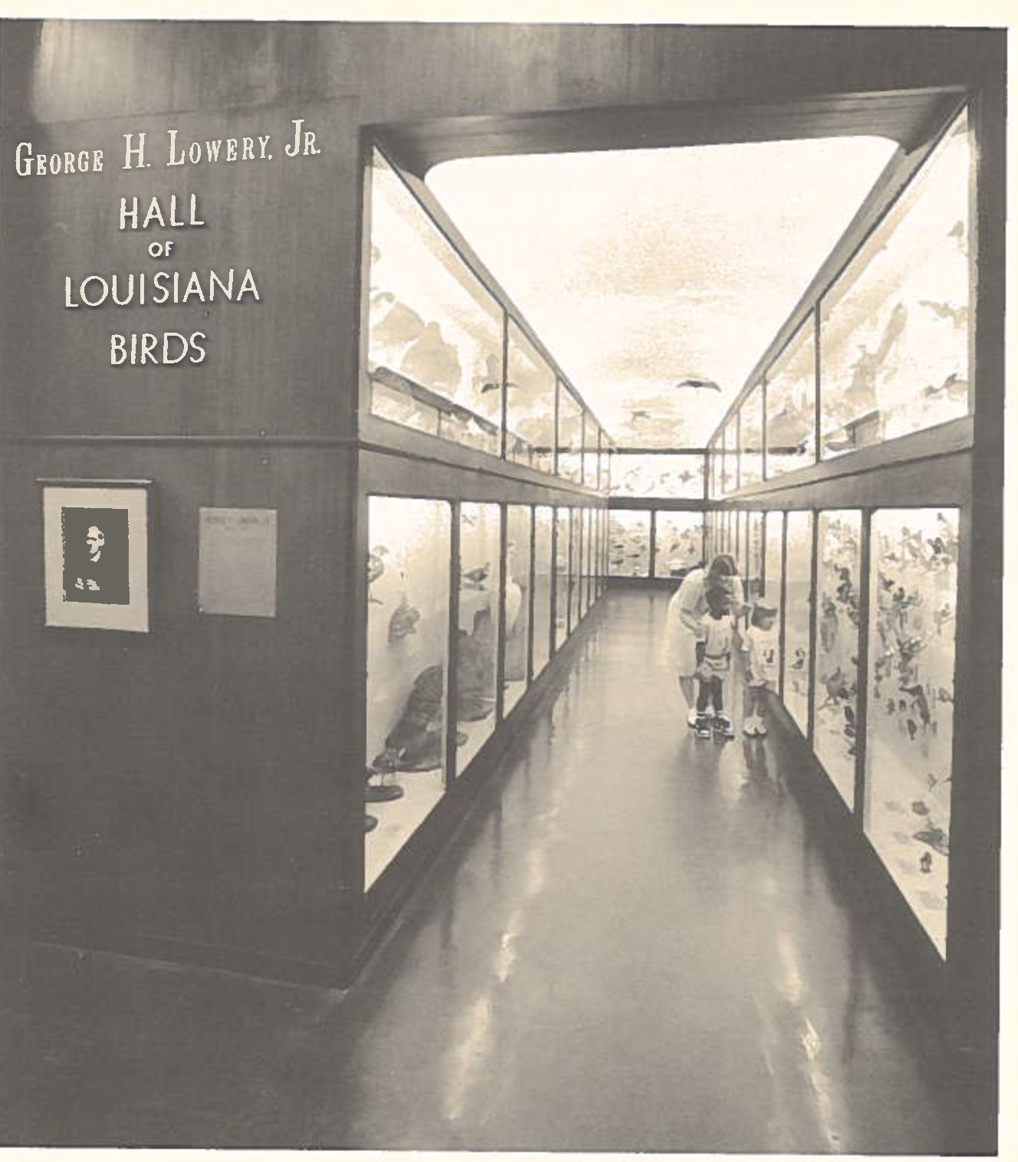
George Lowery knew exactly what he wanted Daigre to do. Daigre1s preference was to start out by recreating an improved edition of the waterfowl exhibit he worked on in Shreveport in 1947. Lowery 11insisted11 that a gallery of

Louisiana birds be given foremost priority. A compromise was effected in that Daigre would work on the ga11 ery "piecemeal" over time and do the preliminaries on the waterfowl diorama simultaneously. Lowery's intention was to display as many of Louisiana's 378 species of birds as could be incorporated into a corridor of showcases. A walk down that aisle would afford viewers an opportunity to appreciate their State's ornithological treasures, all properly mounted and identified. Lowery believed that "no aspect of natural history is more fascinating to a greater number of people than the study of birds.11 A gallery could serve as a medium by which that natural curiosity might be accelerated. Daigre and his assistants did the preparation and mounting of the specimens, constructed the display cabinets, painted a sky scene on the ceiling, and suspended several "in-flight" specimens from the overhead.
There is no finite completion date for this beautiful exhibit. In a sense, as Robert Newman pointed out, the gallery was designed to remain unfinished, since Lowery expected new species of birds to be discovered (and offici­ ally approved) indefinitely. As of this decade, for example, the number of species has risen to 432, although

they are not all represented in the showcases. In 1985-86 the blue identification cards were installed by Dr. John O'Neill. On September 9, 1986, in deference to the Museum's fiftieth anniversary and to the accomplishments of its founder and first director, the gallery was christened "The George H. Lowery, Jr. Hall of Louisiana Birds" during the second annual meeting of the Patrons Association.

* * *

WATERFOWL IN A LOUISIANA MARSH IN EARLY SPRING (1955)

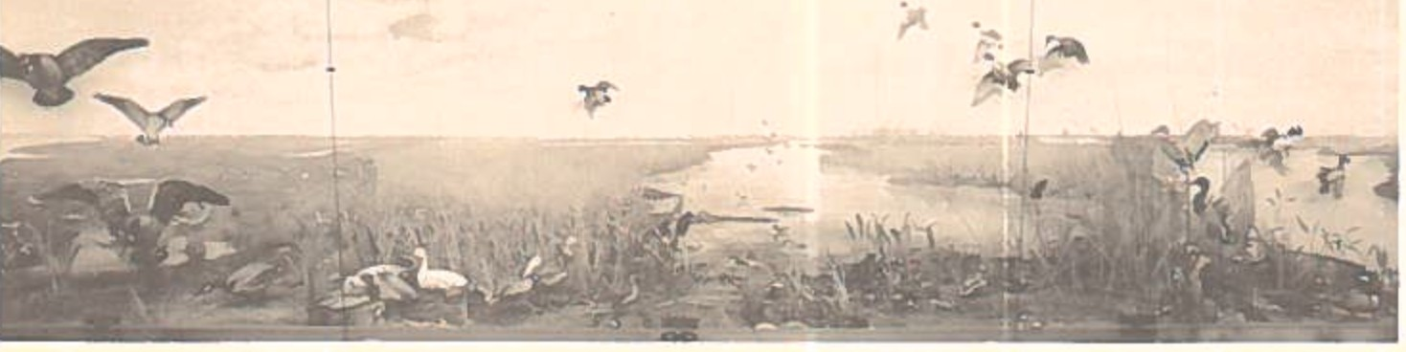

In February, 1955, George Lowery told LSU's comp­ troller, Daniel C. Borth, that "the construction of museum exhibits is a slow and tedious business -- that is, if we are to achieve the goal of perfection that we have set for ourselves." When the Museum opened its doors to the public on Sunday, March 27, 1955, there was overwhelming agreement that the goal had been reached. The era of the diorama had dawned in spectacular fashion. Lowery hoped to delay the official premiere until more dioramas were completed but

decided that it was politically unwise to wait any longer. Issues such as establishing a docent program, improving the appearance of the main exhibit hall, and planning for crowd control had to be subordinated to the need to show LSU, and the public, that something tangible had been achieved since 1950. If the Museum (as promised by Lowery) was 11to play an important role in the teaching of the biological sciences to Louisiana's schoolchildren" then a beginning had to be made before people lost faith in the entire project.
Lowery was not disappointed in the initial returns. Between March 27 and May 9, over 4,000 citizens visited the Museum. At least thirty percent were pupils in local ele­ mentary schools. Popular reaction was very positive. Some observers thought that LSU Is Museum had "outdone every other museum in the country..." insofar as dioramic presen­ tations were concerned. Ambrose Daigre, who was not present for the opening, was the object of many compli­ ments, and deservedly so. Lowery spoke for everyone when he wrote to a close friend, 11I do think that Ambrose Daigre did a magnificent job, and demonstrated beyond all question

his ability to build a series of habitat groups of really fine qual ity.11
Visitors and newspaper reporters were stunned by the size of the waterfowl exhibit. It was thirty-nine feet by ten feet, which, Daigre said, made it "the continent's largest habitat group devoted exclusively to birds.11 Behind the enormous glass front were sixty-two geese and ducks in various poses -- standing, flying, and landing. Observers were intrigued by the illusion that a number of the birds seemed to be "suspended in air without means of support," a piece of professional legerdemain devised by Daigre with the help of wire and tape. Many people wondered how the vegetation survived so well indoors. The answer, of course, was: most of it was not 11real.11 Some of the grass was dried and painted, but nearly all the vegetation was made from "wax and cellulose acetate." The 11water11 in the diorama was plastic, conveniently rippled by hand at points where the waterfowl were touching it. The exhibit was meant to duplicate 11an actual scene in Cameron Parish," one of the "largest wintering areas for waterfowl in North America."

The vast dome-shaped backdrop in the diorama was designed and engineered by Professors Ollie "0. J." Baker (architectural engineering) and Wayne P. Wallace (civil engineering) of the LSU faculty.. Daigre made kodachrome slides from photographs taken in Cameron Parish, projected them onto the dome structure, and painted over the projec­ tions in oils (a practice he gave up thereafter in favor of spray painting). This was so deftly done that the diorama Is foreground b1 ended with the 11mi1 es of 1 owlands11 in perfect perspective. Astonishing a1so was the i nnova­ tive use of recorded sounds. By pressing a button visitors were treated to a narration and the sounds of birds in their natural habitat. A reporter from the New Orleans Times-Picayune referred to this phenomenon in a short piece entitled "The Quack Is Real" as follows: "The [bird] calls, recorded in the field... make you feel the mounted birds are in flight.11 The consensus was that the addition of the recorded messages brought a degree of realism to the diorama that was lacking in most national exhibits.
Nearly all the monies for the preparation of this exhibit ($4,000) were supplied by the Louisiana Wildlife and Fisheries Commission 11in the interest of [the] conser-

vation of Louisiana's natural and wildlife resources 11
Four months after the waterfowl diorama was opened to visitors the Commission awarded the Museum a continuation grant of $8,950 to defray the expense of erecting more exhibits, a gesture gratefully acknowledged by the LSU Board of Supervisors on August 3, 1955 -- the very day the Board confirmed George Lowery's designation as Boyd Professor of Zoology. It was a banner year for Lowery, perhaps his best since 1950. The Museum was launched at last, he was one of only five Boyd Professors on campus, and the first edition of his acclaimed Louisiana Birds was published in October. On November 2, he was inducted in Omicron Delta Kappa, a national honorary leadership society. Not many of his remaining twenty-three years would witness such a coalescence of successes. At age forty-two, his star had risen to new heights in the professional constellation.
* * *

AT THE EDGE OF THE RAIN FOREST (1955)

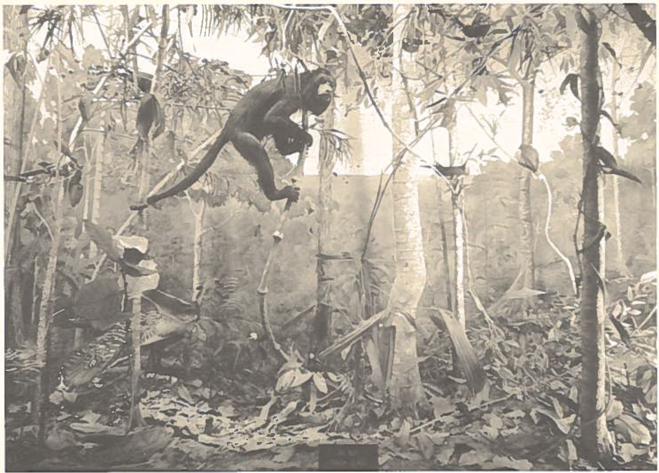

Well before the waterfowl exhibit was completed Lowery was thinking ahead about additional habitat groups. He realized that the Museum could not rest for long on the laurels of one diorama, a bird gallery, and an insect cabinet. The "dream plan" called for ten dioramas. Lest the entire project drag on for decades, one diorama had to be finished each year, on the average. So, while Daigre was working at the maximum to meet that schedule, Lowery was busy tapping every likely source of funding. LSU was

not in a position to come forward with the $30,000 it would take to construct the first nine dioramas. Staff salaries were all the University seemed willing to provide. Fortu­ nately, by the early 1950's Lowery's reputation was magnetic enough to draw commitments from some of his "contacts."
It was understood that the second diorama would por­ tray the essence of a "tropical rain forest." Where was the most convenient, promising location for the collection of appropriate flora and fauna? Among his friends Lowery counted one Mr. H. A. J. Evans, president of the Dixie Lumber Company of New Orleans and the United Fruit Company. Evans was doing a thriving business with British Honduras (renamed ''Belize" on September 21, 1981). Dixie Lumber was a subsidiary of British Honduras Distributors, Ltd., of London and specialized in the importation of mahogany. Lowery was well acquainted with the territory, having done field work in the adjoining Yucatan peninsula. Following an exchange of letters Evans consented (December 1, 1954) to finance the Museum's expedition to British Honduras. Since the Honduran dry season fell between January and May
there was not a moment to waste. Maps, permits, and

transportation arrangements were secured in record time. Two graduate students, Stephen M. Russell and Douglas A. Lancaster, were to proceed to the site and Ambrose Daigre was to join them as soon as possible.
Russell and Lancaster left New Orleans on February 10, 1955, aboard the S.S. La Playa. They had their twelve crates of supplies unloaded near camps affi 1iated with Dixie Lumber, set up headquarters, and waited for Daigre, who arrived in British Honduras on the afternoon of March
13. Within a fortnight Daigre and his companions had trapped and skinned the diorama's celebrity, a howler monkey, collected and mounted other specimens, and made plaster casts of vegetation peculiar to the area 1s then largely unexplored jungles. Daigre took photographs of a "suitable view" for use as the diorama's setting. Daigre returned to Louisiana on April 13, seventeen days after his waterfowl panorama was unveiled at LSU, and immediately began to prepare the rain forest exhibit. Russell and Lancaster returned by air on May 10, bringing with them 300 tropical bird specimens for the Museum's growing collection and stories of high adventure in the jungles. They also brought back an unwelcome stowaway. Early in June both men

were stricken with infectious hepatitis and spent the rest of the summer in the hospital.
The rain forest diorama was completed just before Christmas, 1955. Ten feet wide by ten feet high, it offered the viewer an intimate introduction to tropical life. The workmanship evoked considerable attention from all quadrants of Louisiana. It was with no little pride that Lowery reported to a Museum partisan: 110ne sma11 tree
...had no less than 2,000 leaves, each of which had to be cast from cellulose acetate, trimmed, and then painted with an air brush, all before being attached in its proper place on its particular branch.11 People seemed very interested in how the specimens were caught and prepared under such steamy and hazardous conditions. What about the thirsty vampire bats, roving jaguars, slithery reptiles, and affectionate ticks -- did they not pose threats to the expedition's well-being? Not at all. In Daigre's opinion, 11A man may be safer [in the jungle] than driving in a big city• II
Lowery was happy to have two dioramas finished in the same year. He observed with satisfaction that 6,000 citizens made their ways to Foster Hall since May, making a

first-year total of 10,000 visitors. Zoologists from elsewhere who stopped in while in Baton Rouge stated that LSU1s Museum was rapidly becoming "one of the best Univer­ sity museums in the United States." Lowery believed that the Museum was "already of great value to LSU students and faculty...." As the community readied itself for the Christmas holidays there was a feeling of warmth and accomplishment within the Museum. The "dream" was no longer a matter of speculation. The outlook for 1956 was bright, to say the least.

* * *

MIKE THE TIGER (1956}

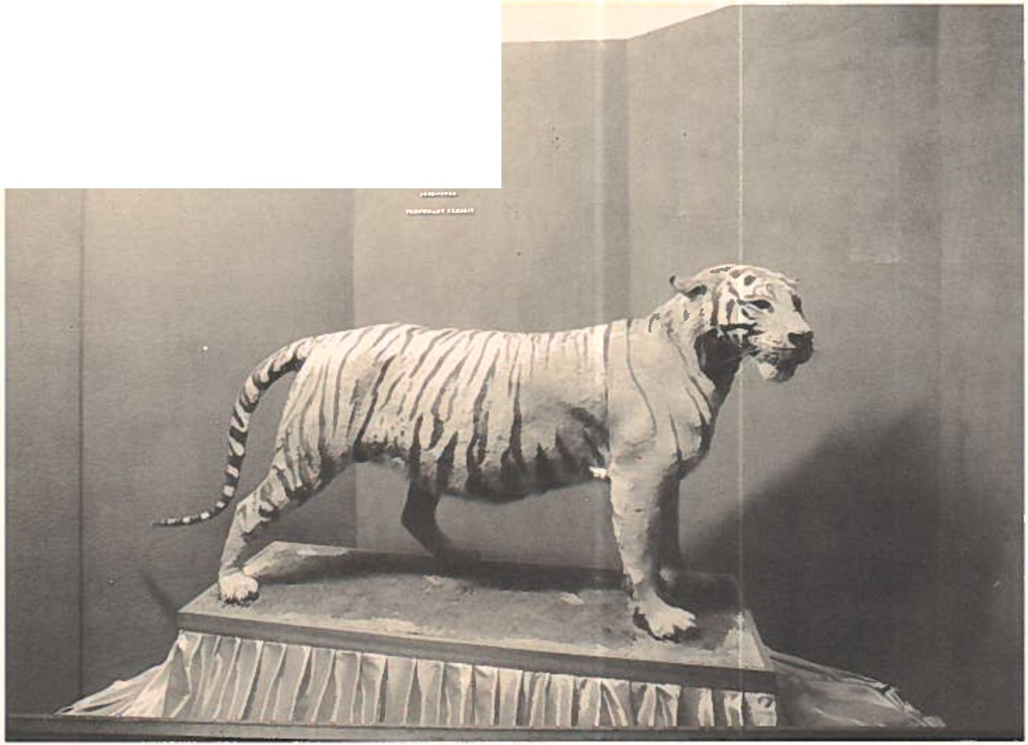
- ; 0 .:,.._
., ' ·,::t;•
.., ·
J:?;

The year 1956 A. D. turned out to be every bit as exciting as Lowery and Daigre expected, as we shall see. The overall plan appears to have included the completion of a "June in the Rockies" exhibit by the end of the year, and preliminary field trips to lay the groundwork for a display "of an Avery Island colony of egrets and herons." Most things were moving along nicely. The original visiting

90

hours were elasticized to accommodate the swelling number of schoolchildren and families who had heard about the Museum's new delights. The public could now come to Foster Hall from 8:00 A.M.-5:00 P.M., Mondays through Fridays; Saturday mornings; and Sunday afternoons. As of March 27, 1956 -- the Museum's first birthday -- over 15,000 people from all parts of the State had visited Foster Hall. They

were captivated by the realism of the entranced by the push-button sound effects.
dioramas and And they were

instructed by the explanatory panels fixed to the walls adjacent to the dioramas, which were composed by Assistant Curator Robert Newman.
Lowery received the Louisiana Literary Award in 1956 for his Louisiana Birds (1955) and saw three of his doc­ toral students receive their degrees from LSU. For his contribution to our understandings about the nocturnal migration of birds he was awarded the Brewster Medal from

the American Ornithologists' Union.4 Certainly he was pleased with media coverage the Museum engendered. For example, a sentence that appeared in the Baton Rouge State-Times (March 26, 1956) typified the sort of upbeat, approving (if rather optimistic) reportage Lowery could anticipate routinely: "If you decide on a quick trip to the Rockies, British Honduras -- or later this year take a look at a mist-shrouded forest of Central America or witness the greenery and blossom that color America's western deserts after a cloudburst -- the doors of the LSU Museum are open." Daigre was a subject of keen interest as the master craftsman of the dioramas. He appeared in State

- The Brewster Medal was struck by the A.O.U. as a memor- ial to naturalist William Brewster (1851-1919), whose contributions to bird study were renowned. Like Lowery, he was a tall, handsome man whose "distinct literary gift" enabled him to publish nearly 400 articles. Brewster was naturally courteous, honest, and unaffected. He was also a perfectionist, a non-practicing but "truly religious" gentleman who displayed 11a certain sincerity and rightness of soul 11, and the devoted husband of a charming woman, whom he loved deeply. Daniel Chester French once said of him: "To all, young or old, rich or poor, his frankness, his cordial manners and deferential attitude appealed." These descriptions apply to Lowery as well, which lends a dimension to his receipt of the medal that is usually overlooked.

newspapers regularly, as a rule in detailed, biographic profiles with snappy titles such as "He Doesn't Just Stuff Birds" (Baton Rouge Sunday Advocate, August 12, 1956). In that full-page feature Lowery referred to Daigre as "one of the most versatile museum preparators11 in the nation, an encomium Daigre had earned many times over since 1952. The litmus test for versatility, and patience, was applied in the summer of 1956 when Daigre was forced to deal with a dead mascot -- LSU's Mike the Tiger.
When Mike died of old age and an acute kidney infec­ tion on Black Friday, June 29, 1956, the LSU campus went into mourning. By the mid-1950's he had become living icon. Born on October 10, 1935, in the Little Rock (Arkansas) Zoo, Mike (originally, 11Sheik11) was purchased with funds ($750) collected mainly by students. His arrival at LSU in November, 1936, was greeted with much "hoopla." Over the next nineteen years his presence at football games was invested with metaphysical properties bordering on the evangelical. Mike was many things: a lucky charm, a sinewy manifestation of the gridiron prowess of his human namesake and, in time, so much a part of the campus ethos that he was bestowed with immortality by

thousands of alumni. Suddenly, Mike was gone. An enormous vacuum was created overnight. His demise was heartbreaking enough, but -- worse yet -- what was LSU going to do with­ out a mascot during the approaching football season? One does not sprint to the nearest tiger farm and rent a cub in haste. What to do? Call Lowery and ask for help? Perhaps a stuffed symbol was better than none at all.
On Sunday, July 1, 1956 -- twenty years to the day of his appointment to the LSU faculty -- Lowery told a Daily Reveille reporter that the Museum would deem it a privilege to mount the late Mike's pelt. He said that Daigre, "undoubtedly one of the finest taxidermists in the United States," was up to the task. If a manikin could be found Mike's reconstituted remains would be displayed in Foster Hall "temporarily" until the proposed "new field house" was ready for occupancy. Daigre was deeply involved in diorama production but he took five days away from his primary job to skin Mike. Lowery, anxious to dispense with this diversion as promptly as possible, began a feverish quest for a manikin. He wrote urgent letters to suppliers in Illinois, Nebraska, Colorado, Pennsylvania, and New York. No one had a ready-made manikin tailored for an 8OO-pound

Bengal tiger. Making one would cost $2,500 and take five months, they told Lowery. At LSU money was scarce -- and the first home footba11 game was just twelve weeks off. Once again Lowery turned to Daigre for emergency assistance. Daigre dropped what he was doing and fashioned a manikin around which Mike's skin could be fitted. The result was remarkable, as usual. There were complications, however. Where would Mike be placed? Like it or not, there was only one option. 11We plan to display him,11 Lowery told alumni secretary T. K. McKnight, 11in one of the spaces already built... for the installation of a habitat group.11 It was done, of course. Mike was behind glass and ready for viewing by September 20. But in the process Lowery surrendered a valuable space set aside for a diorama. Second, Lowery committed Daigre's time and talents
to a project for which there was no guaranteed funding. It seemed fair to compensate Daigre for work that lay outside his regular duties. Daigre was, Lowery told McKnight, "devoting all his spare time to the task,11 "furnishing all materials,11 and "paying for the help [from Philip A. Sandberg] that he requires.11 But how much should Daigre receive, and from what source should the compensation come?

When all was said and done, how did the Mike the Tiger affair turn out? As visitors to Foster Hall can see for themselves, Mike's "temporary exhibit" became permanent. The "new fie 1d house" Lowery spoke of in 1956 was not opened until November, 1974, and, by then, Mike and his recorded roar had evolved into a traditional feature in the main exhibit hall. The revered cabinet he occupies was needed badly in the early 1960 1 s when the Museum was in extremis for more diorama space, but there was no feasible way to evict Mike and preserve the peace. Regarding Daigre's reimbursement, that issue was resolved amicably. McKnight canvassed the alumni and received sufficient donations to give Daigre the $750 that Lowery recommended he be paid for the work on Mike.
And what about LSU's mascot dilemma? Despite the seemingly insurmountable problems raised by those caught up in the summer frenzy, everything worked out on schedule. Renovations to the tiger cage were completed in time to welcome a new occupant. He was purchased for $2,500 from the Audubon Zoo in New Or1eans. Best of a11 , Mike I I was ensconced in his campus home before the game with Texas A&M. Meanwhile, back at Foster Hall, overshadowed but not

entirely forgotten, Mike I began his thirty-year tour of duty among the lesser species. It took his jaunty succes­ sors awhile to work their magic on the minds and bodies of LSU footba11 pl ayers. The LSU Tigers won three games and lost seven in the fall of 1956. The glory years were still several seasons away.

* * *

IN THE ROCKIES ABOVE TIMBERLINE (1956)

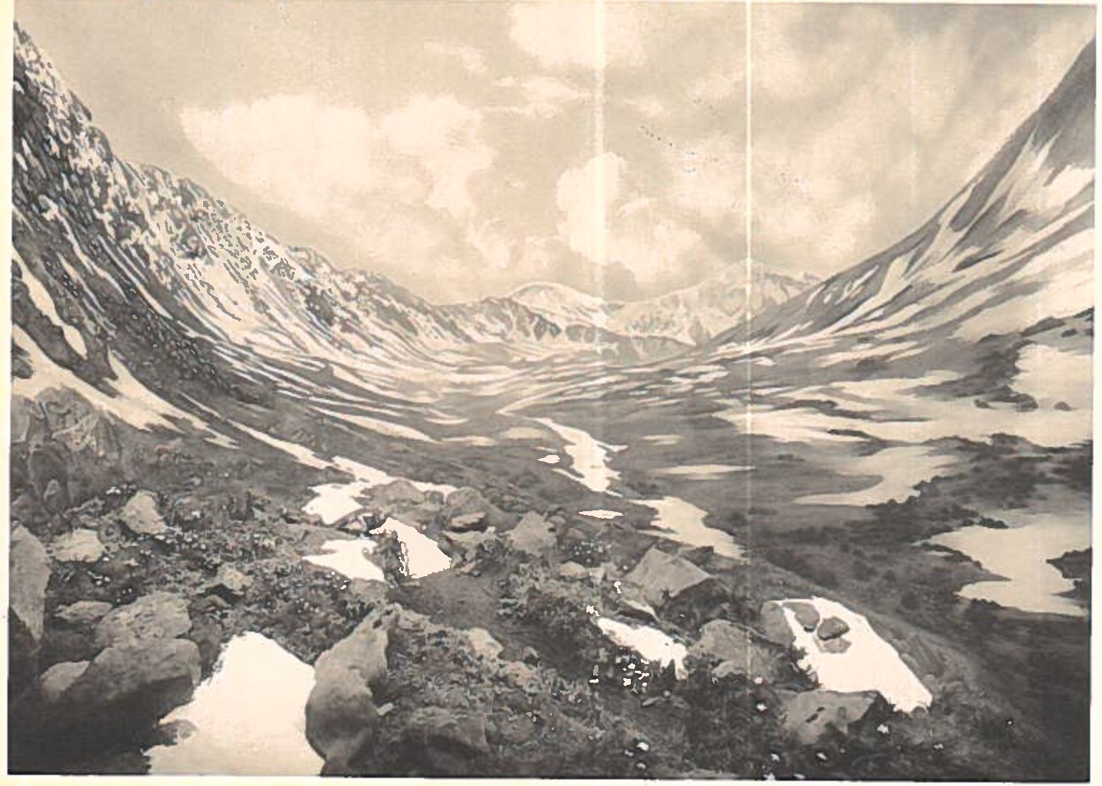

It was this diorama that was thrown somewhat off schedule by the death of Mike the Tiger. Daigre's plans to go west in the early summer of 1956 were delayed two months. When he arrived at Graymont, Colorado, sixty- eight miles northwest of Denver, it was no longer "June in the Rockies." At 9,000 feet things were different in August from what they would have been in June, hence the alteration of the title of the diorama. Each day for several weeks Daigre moved above the timberline "to trap

speicmens and study alpine flowers." When he returned to LSU his major task was to create a backdrop that sloped gently toward a distant, snow-capped range. How well Daigre succeeded was captured by newswoman Martha C. Towns of the Shreveport Times in her article, "Museum Windows Reflect Sights, Sounds of Nature":
At your feet are bright wildflowers, overhead are fleecy white clouds and in front of you a mountain range stretches into infinity. It doesn It take a trip to the Rocky Mountains to see this scene, although it is there if you know where to find it. A trip to the Rockies is as near to you as the LSU Museum of Natural Science....
While Daigre was finishing the "Rockies" exhibit, and sorting out his Avery Island finds, Lowery was working on drafts of the fifth edition of the A.O.U. 1s Check-list of North American Birds and searching for funds to support the construction of future exhibits. At this point it would be useful to know what Lowery said to potential benefactors about the costs inherent in creating a diorama. He revealed such details in a letter to Mr. Jesse M. Knowles of Lake Charles dated January 18, 1957. Knowles was a kingpin in the Stanolind Oil and Gas Company and a

prospective donor to a whooping crane exhibit. Lowery told him:
A word about construction cost is in order. When we asked for $3,000 to cover the cost of construction of this exhibit, our figure was based on what we have found to be our basic cost on other habitat groups. This figure is what we have asked of, and received from, other patrons of other exhibits. The figure does not cover our overhead expenses, such as the salary of our preparator and taxidermist or, as a matter of fact, any expenses other than actual construction cost. The back of these exhibits are plaster domes, reinforced with steel. The dome-shaped structure is the surface on which the artist paints the background scene, which is made to tie-in with the artificially repro­ duced foreground in such a way as to often defy detection as to where the two join. The plas­ ter-steel domes and polished plate glass win­ dows cost slightly over $1,600. The second and often much greater cost in connection with these exhibits is associated with the manufac­ ture of the artificial accessories. We have to employ a group of students on an hourly basis to do this time consuming work.
Lowery need not have said so in his letter to Knowles, but he and Daigre were ably assisted by a cluster of female volunteers, some of whom prepared "artificial accessories" under Daigre's supervision for upwards of four years. They made molds for (and painted) 11leaves11 and 11flowers11 for Daigre to affix to diorama foregrounds, gathered vegetation for the exhibits while on field trips, and performed other

tasks for the Museum between 1954 and 1960 simply because they enjoyed making a contribution -- and because Lowery was a very persuasive recruiter of free 1abor. It is not an exaggeration to say that Lowery's schedule for comple­ tion of the exhibits would have fallen farther behind than it did were it not for the dependability of volunteers such as Barbara Bodman, Imo Brown, Marjorie Duchein, Winifred Winfree, and Lowery's daughter, Jeanette, the unsung heroines of the "dream plan1s11 formative years.

* * *

A HERONRY IN SOUTH LOUISIANA (1957)

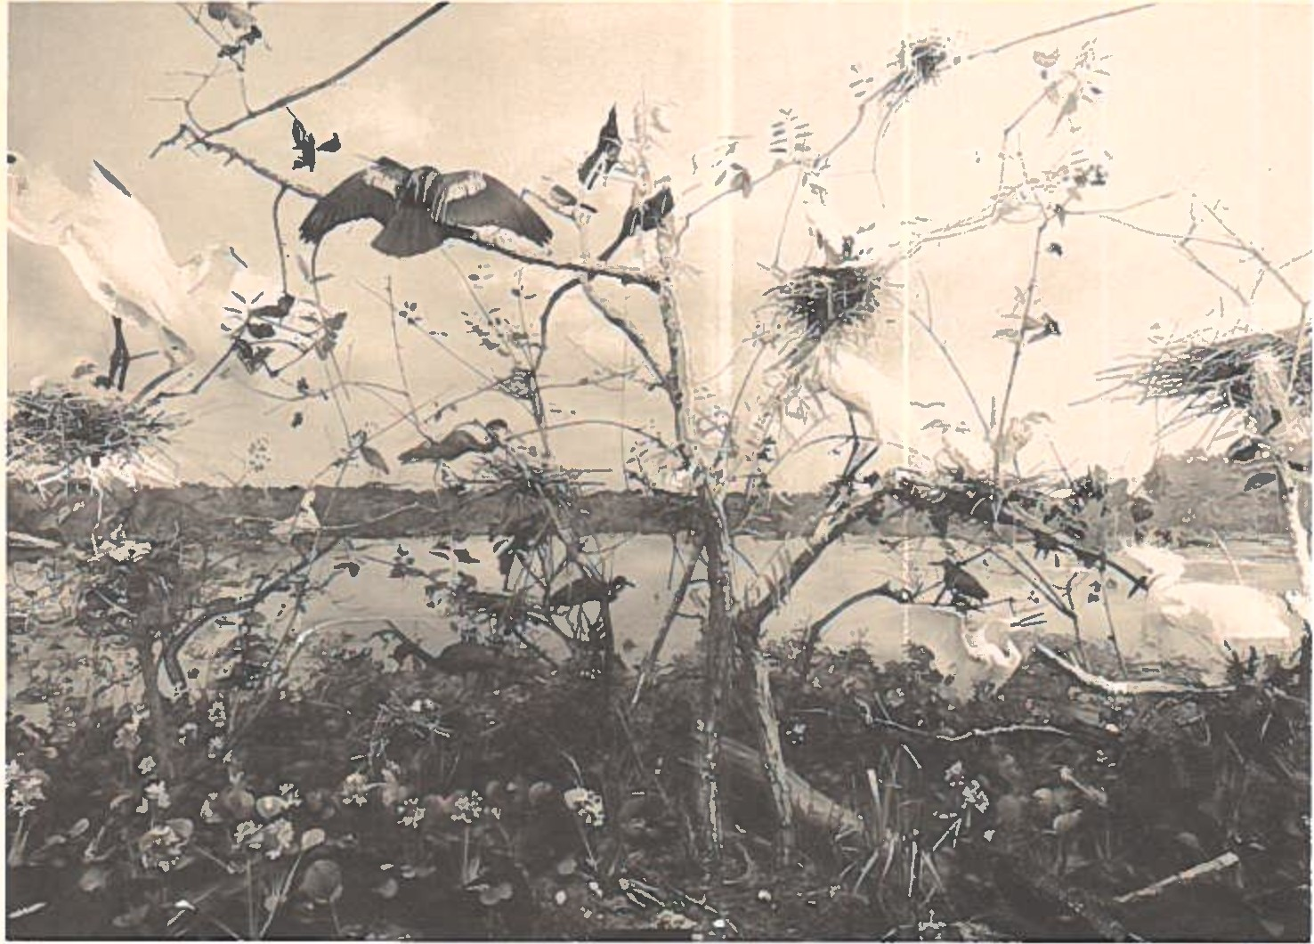

Shortly after Daigre's waterfowl exhibit opened in March, 1955, Lowery established contact with the family of the late Edward A. Mcilhenny, the "benevolent baron" of Avery Island. As we noted earlier Lowery and Mcllhenny were close personal friends in the 193O's and 194O1s. When they first met Mcilhenny was nearly sixty and well known as one of Louisiana's "highly competent naturalists.11 He was also a photographer, taxidermist, animal breeder, arctic explorer, artist, conservationist, and chief executive of

the lucrative Tabasco Sauce Company. He was a landscape architect as well, being the person credited with the design of the grounds that grace the 11new11 State Capitol Building (1932). Mcllhenny died on August 8, 1949, at age seventy-seven. He was a nonpareil , the likes of which we see but once every generation or so.
In his memorial to Mcilhenny in the Auk (1951), Lowery spoke of him with much affection, reminding us that 11M'sieu Ned11 was very i nfl uential in the development of wildlife management practices, and that he 11contributed materially to Gulf Coast ornithology11 in many ways -- not the least of which was his founding of a rookery known as 11Bird City11 in 1895. In his Louisiana Birds (1955), Lowery cited seven of Mcllhenny's numerous publications and said of his patron:
To Mcilhenny we are especially indebted for his great work in the field of wildlife conserva­ tion and for his extensive bird-banding accom­ plishments...Mcilhenny is credited with having banded in his lifetime the amazing total of 189,289 birds, mainly ducks. Data obtained from returns on these bandings were eminently important in plotting migratory routes follow­ ed by North American birds.
After Mcilhenny died Lowery felt obliged to pay public tribute to him somehow. A diorama that depicted a portion of the 11Bird City11 nesting rookeries seemed fitting, but

there were no funds available for that purpose. Thus, his letter of May 9, 1955, to Edward M. 11Ned11 Simmons, husband of Mcllhenny's daughter Pauline (11Polly11), asking if the family would consider donating the $3,000 the project required. Lowery told Simmons that Mcilhenny was a "wonderful friend" whose memory he would like to perpetuate by placing a bronze tablet on the public side of the exhibit. On July 20 Lowery received a $3,000 check from Simmons I wife on beha1f of herse1f and her two sisters, Leila and Rosemary. He forwarded the money to President Middleton for presentation to the LSU Board of Supervisors. On August 3, 1955, the Board gratefully accepted the restricted gift and authorized Lowery to proceed with the construction of the panorama. Nine days later Middleton sent a "thank you" letter to all three of Mcllhenny's daughters.
Lowery to1d Simmons he expected the heronry diorama would be ready in two years -- and it was. Before Mike the Tiger played havoc with Daigre's schedule he went to Avery Island in the spring of 1956 to collect specimens and take the necessary photographs. He began work on the habitat group early in 1957 and completed it in June. It included

1132 birds, an alligator, a bull frog, and a water moccasin, all appearing lifelike among water hyacinths and trees.11 Daigre's latest effort was a stunning success. Lowery was jubilant. 111Bird City' still exists -- a living monument to the cause of conservation and to its founder,11 he told an interviewer. In the 1980's more than 20,000 birds 11use this area as a nesting site" each year, an ongoing phenomenon that would pl ease both Lowery and Mc11 henny, were they with us still.

* * *

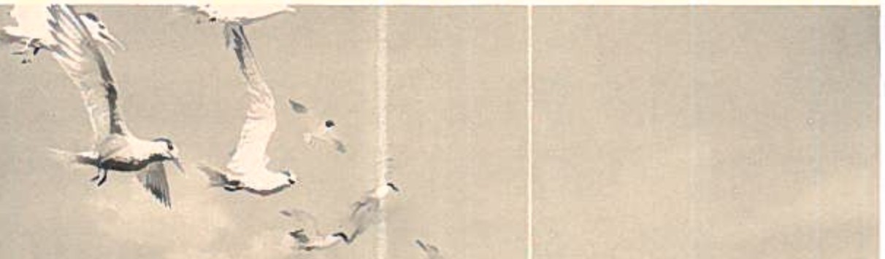
BIRO LIFE ON A COASTAL ISLAND {1958)

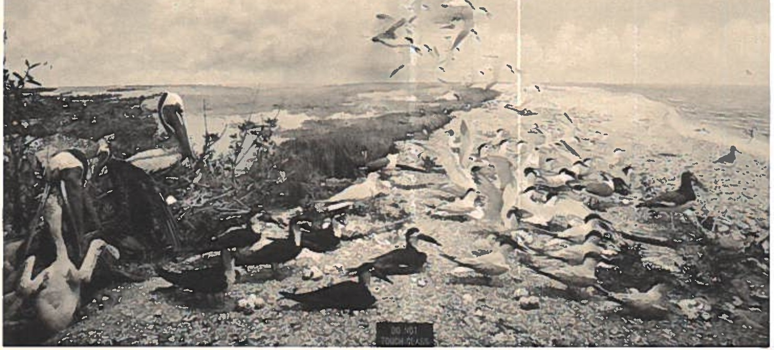

During the period July, 1957-March, 1959, the "Coastal Island" grouping was the only new exhibit made available for public viewing. Financed in part by a grant from the Louisiana Ornithological Society, it depicted "a scene on a coastal island in the midst of a seabird nesting co1ony 11
In the diorama it is mid-June, sometime during World War II. If one studied a current, full-sized map of Louisiana, the "barrier islands" would be seen to form a

crescent extending from Isle au Pitre on the eastern tip to the She11 Keys on the west. As the eye moves along the crescent the Chandeleur and Breton islands appear to be fifty miles east of the Plaquemines Parish mainland. The diorama panel tells us that, "On these lonely, uninhabited islands.are some of the largest sea bird colonies to be found in the United States or its territorial waters." Daigre's competence is clearly demonstrated in this exhibit, particularly in the blending of in-flight speci­ mens with their smaller counterparts on the backdrop, and in the sumptuous gatherings of clouds on the distant horizon.
Although diorama production was slowed somewhat between 1957 and 1959, there was considerable activity on other fronts within the Museum. In July, 1957, an "expertly mounted" Adel ie penguin was given to Lowery by the U. S. Navy. Lowery was pleased to have a smartly­ dressed bird "which the University could not have obtained by its own expeditions" and thought it likely that his new acquisition would be placed in "one of the Museum's special showcases" set aside for "rare and unusual" specimens. To date, the penguin has not made his debut. In August,

Lowery was elected Second Vice-President of the American Ornithologists' Union, the first step toward the Presidency (1959) and further national prominence. The two doctoral students who tamed the jungles of British Honduras in 1955, Stephen Russell (Ph.D., 1962) and Douglas Lancaster (Ph.D., 1960), brought distinction to themselves and the Museum when they were given the Marcia B. Tucker Award for 1957 and 1958, respectively. The Tucker prize was reserved for "outstanding graduate students in the United States in the field of ornithology."
The year 1959 began auspiciously enough. On January 9, LeRoy Williamson, an LSU forestry student, literally stumbled across the shoulder blade of a 25,000-year-old mastodon along the banks of Tunica Bayou in West Feliciana Parish. Further excavation revea1ed that Wi 11i amson had discovered "the most complete mastodon skeleton ever found in Louisiana." After a drying out period in the attic of the Geo1ogy Bui1ding the ske1eton was turned over to the Museum of Natural Science. Lowery and Daigre both contri­ buted to the preparation of the exhibit, 11A 12,000-Year-Old Giant From West Feliciana Parish," which was pronounced complete in April, 1959. Two days after Williamson's

serendipitous find the Baton Rouge Sunday Advocate for January 11, 1959, emblazoned the front page of its feature section with the headline "Natural History [sic] Museum at LSU Is Becoming Extremely Popular.11 Citing healthy atten­ dance and the 11ever-growing interest of the 1ayman in nature" as his major touchstones, writer Jackson Davis gave the Museum and its staff a bouquet for their achievements.
11 LSU's Museum,11 he stated, "does have a forward-looking
approach that bids fair to make it not only a Baton Rouge landmark, but also...a museum that will be known throughout the nation. 11 Lowery, determined to keep the Museum from becoming a 11sideshow,11 wanted the displays to always be "informative, accurate and interesting." Certainly the 3,462 schoolchildren who visited Foster Hall in May, 1958, believed the exhibits were all of that and more.
The Museum may have been "forward-1 ooki ng" but when Lowery looked to the fore he was worried. He felt the Museum was "rapidly approaching the most vital crisis of its 1 ife11 in 1959. It was at a crossroads and there were only two ways to turn. One road led to "further growth and fulfillment of the Museum's educational objectives," the other to "drastic curtailments and...serious consequences."

What was the cri tica1 factor that would affect the route taken? 11SPACE,11 Lowery exclaimed in his 1958-60 biennial report to the administration. Lowery asserted that if the Museum did not retrieve most of the footage surrendered to the Art Department in 1950, diorama construction would 11come to a halt,11 Daigre would leave LSU, research activ­ ities would be severely hampered, and LSU would lose money from potential donors. Inattention on the part of the administration could lead to the closing of LSU's 11front door,11 through which the pub1 ic streamed to see the only 11academic aspect" of University life they were privy to. Lowery, it happens, was not being an alarmist or "crying wolf." He predicted that by 1961-62, if LSU did nothing to alleviate the Museum's staffing and space problems, 11disastrous consequences" would ensue. As we have come to recognize, he was absolutely right.

* * *

THE LOUISIANA PRAIRIE LONG AGO (1959)

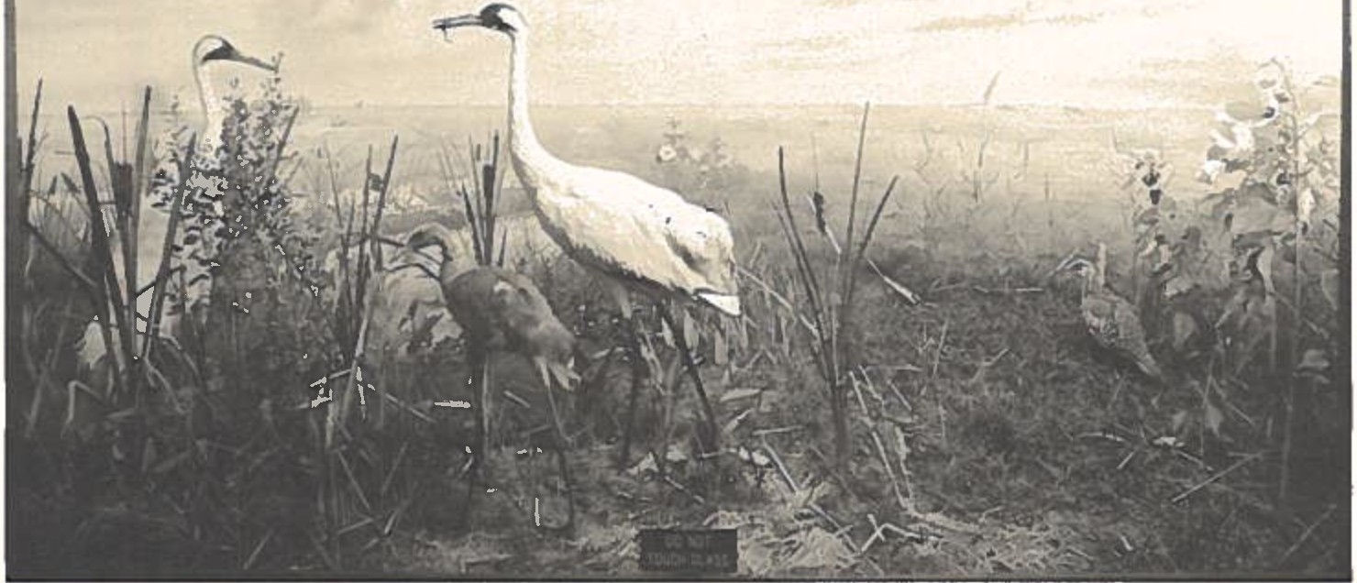
..

The dubious distinction of being the diorama with the longest gestation period belongs to this exceptional exhibit. Early in June, 1954, Lowery visualized a display that would "depict a natural scene of the primitive era of southwestern Louisiana when Attwater Prairie Chickens and Whooping Cranes still nested there and when even herds of buffalo wandered into the area.11 Procuring a buffalo did not interest him particularly but the Whooping Crane (Grus americana) definitely did. Lowery announced in June that

Dame Fortune had smiled on the Museum. He was able to
obtain a mounted crane from the U.S. National Museum of Natural History in Washington, D. c.5 The accession of the
crane filled out the Museum's collection of Louisiana birds, which stood at 378 specimens at that time.
In 1954 cranes were of special interest to ornitholo­ gists because it was estimated that there were only twenty­ five of the "almost extinct and rapidly disappearing" birds in existence. Very few people had ever seen one of these lanky birds, alive or deceased. In 1940, observers counted thirteen cranes in the marshes and prairies of southwestern Louisiana, but storms and severe floodings in the area

- A Smithsonian subsidiary, the National Museum was opened formally in 1911. Today over five million visitors roam through its public exhibit halls annually. It is financed by the Federal Government and by tax-deductible donations, and houses sixty-four million items in its seven disciplinary departments. From the outset it served as a model for budding museologists. It featured dioramas, exhibit cases, and other static groupings typical of the "show-all-and-tell-little" school of museum display prevalent during Lowery's and Daigre's youth. At most museums, the state of the exhibitory arts has progressed far beyond that point. At LSU things remain very much as they were a generation ago, due primarily to the lack of support for expansion and modernization programs.

reduced that number to seven and the rest were slain by hunters -- except for one female, "Josephine." Thereafter, only one crane was sighted in Louisiana. Captured in March, 1950, it was taken to the Aransas Refuge in Texas. It did not survive captivity, which left "Josephine" to be mated with two males named 11Pete11 and "Crip." In late May, 1956, "Jo" and "Crip" became the parents of a rust-colored chick. The 111ittle whooper" caused great but short-1 i ved rejoicing among naturalists. To everyone's sorrow the baby crane died in the Audubon Park Zoo in New Orleans of a lung infection on July 13, 1956. Stuffed and mounted, it was "loaned" to LSU by the Audubon Park Commission on December
13. 11We have the only bird in the world in natal down," Lowery reported with pride. Earlier that fall a local newspaper told its readers that the crane's "showcase... will be completed within the next few weeks," a prophecy that fell short of its mark by two-and-one-half years. And now to the perennial question: how was this diorama to be funded? In a letter dated January 18, 1956, Lowery asked Mr. Jesse M. Knowles of the Stanolind Oil and Gas Company of Lake Charles to underwrite the cost of the exhibit at a level of $3,000. In May, Knowles told Lowery

that Stanolind would provide LSU with $1,500. While Daigre was working on Mike the Tiger, the "Rockies," and the Mcllhenny exhibits Lowery was trying to locate additional donors, without result. In December, 1956, and January, 1957, Lowery made several more attempts to persuade Stanolind (by then, the Pan American Petroleum Corporation) to come forward with the other ha1f of the $3,000. He praised Pan American's land management practices and sensi­ tivity to wildlife conservation in Cameron and Vermilion parishes over the years, and said it seemed 1ogica1 that the Corporation should sponsor a crane family group that would be "unique among the museums of the world." Pan American did not see the logic in that argument. On February 18, 1957, Knowles reiterated his position in a note to Lowery: the ceiling was still $1,500. Not one to be caught without an alternative, Lowery petitioned the Louisiana Wildlife and Fisheries Commission for the funds. On March 30, 1957, the LSU Board of Supervisors officially accepted $1,500 from the Commission, thereby releasing Lowery to move ahead with his plans. Daigre began work on the diorama in the summer of 1958.

The opening of the "Prairie" habitat group in March, 1959, was accompanied by much fanfare on campus and in the media. "Whoopers Now on Display at LSU," one newspaper announced. Daigre was cited for his painstaking prepara­ tory efforts and the careful • way 11the ecology was recreated...." Lowery was quoted as saying that the display was 11the most unique of our six completed exhibits" which would "attract many more visitors to the LSU Museum.11 It was conceded by all parties that for those people who would never see a Whooping Crane -- and that meant almost

everyone
Ha11.

"the next best thing" could be found in Foster

* * *

IN VIRGIN BOTTOMLAND FOREST (1960)

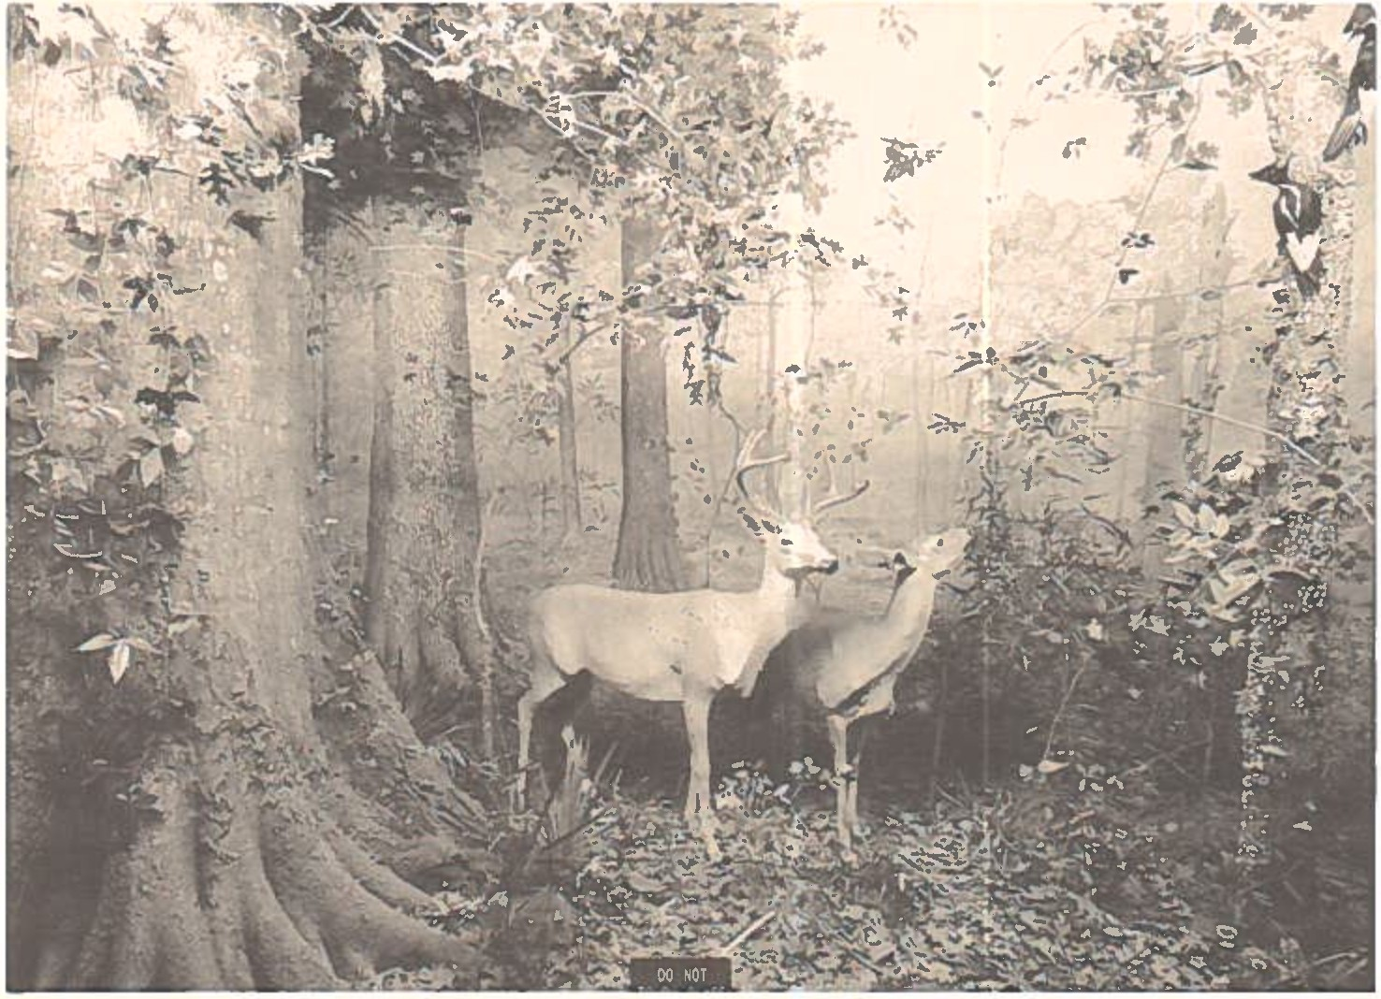

The Whooping Crane panorama was the first in a sequence of three displays Lowery and Daigre wished to do 110n Louisiana wildlife habitats which no longer exist in their ori gina1 form. 11 The 11bottomland forest11 was the
second. It was completed in early October, 1960. The stars of the diorama were (a) a pair of White-tailed deer (Odocoileus virginianus), (b) two large Ivory-billed Wood­ peckers, and (c) a truncated Nuttall oak tree. They were placed in a facsimile of a wooded swamp in Madison and

Tensas parishes in northeast Louisiana. Until the early 19401s the bottoml and covered an area of approximately 81,000 acres. By 1960 that tract had been reduced to 150 acres.
Lowery and Daigre selected the buck and the doe personally. During a visit to J. W. McLemore1s farm in
Tensas Parish they scanned the local deer population with binoculars and targeted the pair they wanted.6 Photographs
of the general environment and of 11individual plants, trees, and...branches II were taken for use as references. Daigre prepared the deer and supervised the reproduction of the flora. After the diorama was done and opened to public scrutiny, onlookers were struck by the realistic stances of the deer, the result of a finely-honed practice known to Daigre as 11posing.11 On that topic he once told a reporter that, 11For posing, one must have a good knowledge of the animal in its environs. Good posing imparts the lifelike

- Lowery's expertise as a mammologist is evident in his section on White-tailed deer in The Mammals of Louisiana and Its Adjacent Waters (1974), pp. 487-99. It is a sensitive, literate passage that exemplifies his lifelong grasp of a discipline that he ranked second only to ornithology.

quality to the specimens which is needed to make it an integral part of the whole exhibit." Popular reaction was proof that Daigre possessed that 11good knowledge" and (as he once said) 11a certain amount of artistic ability" to go with it.
Daigre did not prepare the woodpeckers. They were collected in Franklin, Louisiana in 1899 and inherited by the Museum. Measuring about twenty-one inches long, the resplendent birds made their "last stand11 in the State's wooded swamps, Lowery explained to visitors. Addicted to a steady diet of "betsy-bugs11, the woodpeckers were in a gourmet's paradise in a virgin forest, where the prolifer­ ation of dying and defunct trees provided "an ideal habitat" for the ravenous bugs. When the forests were decimated the woodpeckers were deprived of their main meal and became all but extinct. For example, between 1943 and 1960, Lowery said, there were no reports of these wood­ peckers within Louisiana -- nor were there enough specimens in national collections for ornithologists to study. Lamenting this disintegration in his Louisiana Birds, Lowery exclaimed: 11! wonder what natural beauties we shall have, aside from the mountains and the sky, a hundred years

from now!11 It is very likely that the birds in this diorama will be the only specimens Louisianians will see in their entire lifetimes.
When Daigre reminisced about the construction of the 11bottomland forest" exhibit he recalled that it was the amputated oak tree that "received the most attention'' from sidewalk superintendents. The hefty red oak was taken from the property of Mr. Erle M. Barham of Oak Ridge, Louisiana
-- but not without a mighty struggle. Three feet in diameter at the chest-high level the old Quercus nuttallii stoutly resisted being removed from its arbor. Modern technology prevailed, however. The tree was cut off at a height of eleven feet, suspended with a block and tackle so its roots could be wrenched from the soil , loaded on a trailer, and delivered -- with police escort -- to Foster Hall. There it was hollowed out, sawed in half, and then made whole again inside the display cabinet. At no point did it weigh less than a ton. The surrounding plants were artificially produced by Daigre and his team of assistants. The project was underwritten by Mr. Barham as a memorial to

his father Dr. Ben Edwards Barham (1885-1933).7
At the dawn of the new decade there were several other developments worthy of our attention. Daigre was elected to head the Baton Rouge chapter of the Louisiana Ornitho­ logical Society for 1959-60 and authored a trio of pam­ phlets on the art and science of taxidermy. Lowery was re-elected President of the American Ornithologists• Union for 1960-61. A second, revised edition of his Louisiana Birds was released by the LSU Press in 1960. And, closest to his heart, the Museum's research component was gaining in size and quality with each passing year. He was pleased to tell the LSU administration that recent acquisitions 11considerably increased the intrinsic scientific value of the Museum's research collections.11 As the 19601s drew

- Dr. Ben E. Barham was a country doctor (M. D., Tulane), a veterinarian, and an avid outdoorsman who was highly respected in the Oak Ridge community. His son Erle (1916-76) was a good friend of Lowery. He was a farmer, a member of the State Parks Commission and the Louisiana Wildlife Federation, and a charter founder of the Coulee• Game Refuge east of Oak Ridge. Erle Barham met death in a plane crash while returning home from an LSU football game. His son, Mr. E. Edwards Barham, to whom I am indebted for this information, is a member of the LSU-MNS Board of Fellows and the Louisiana State Board of Regents.

near the total number of catalogued specimens in the vertebrate classes stood at 23,206 birds, 7,918 mammals, and 6,299 reptiles, amphibians, and fishes. Seventy-five percent of the 2,090 specimens acquired between 1958 and 1960 came to Foster Hall through the field work of Museum staff and students. This seemed impressive at the time, but it would pale in comparison with subsequent achieve­ ments. Storm clouds were gathering over the Museum's public exhibits, however.
It is fair to say that the first half of the new decade was a time of turbulence and aggravation for Lowery, Daigre, and the Museum. As the research function of the Museum prospered the educational aspect waned, resulting in a psychological and operational bifurcation that did serious damage to Lowery's designs for museumship at LSU. Between October, 1960, and July, 1964, only two dioramas were comp1eted. For a11 intents and purposes, the era of the diorama came to a close in June, 1964. Lowery's hopes for the future went into Foster Hall's attic with exhibi­ tion materials that could not be displayed for lack of space. After three decades of Herculean attempts to raise museumship at LSU to a level of national distinction Lowery

watched his "dream plan" decay in the musty shadows of the Museum's storage areas. By 1966 it was tragically plain that the educational dimension of his dream would not be realized in full. So, consciously or not, Lowery refocused his energies on the Museum's burgeoning research activities and withdrew somewhat from pedagogical endeavors. Daigre turned his attention to taxidermic opportunities that lay outside the University, although he retained his status as curator of exhibits until 1972.
Why did this happen? After thirty years of hard-won progress, why this denouement in the mid-19601s? What forces brought the Museum's educational thrust to a virtual standstill? These questions are best answered in the light of what one might describe as the infamous "du Pont Debacle," a slice of the Museum's history that still gener­ ates comment within Foster's hallowed halls.

* * *

In late 1959, Lowery received a financial downpayment on the Museum's future from Mr. and Mrs. Eugene C. du Pont III of Georgetown, South Carolina. Their patronship,

Lowery thought, was 11one of the most outstanding accom­ P1ishments II of the Museum Is first quarter-century. The du Pont windfall -- $53,000 for the period 1959-61 -- was to be used to reach two goals: (a) to procure materials for a new exhibit hall in Foster Hall 1s east wing, and (b) to "augment the Museum's collections of the birds and mammals of the world. 11 The new "Ha11 of Zoogeographi ca1 Realms 11 would feature seven more dioramas by Daigre depicting scenes from Oceania, South America, India, Africa, and Northern Eurasia. Implicit in Lowery's 11world exhibits11 plan was the conviction that LSU would see the wisdom (finally) in transferring the east wing from the Art Dep­ artment to the Museum. It was natural also that Lowery
would conclude that the enlisting of a donor of du Pont1s
stature would act as leverage in persuading University
authorities to order the transfer. Furthermore, du Pont1s gift was a bonus that relieved LSU (and Lowery) of the need to scrape up sufficient funds. When confronted with du
Pont1s generous donation and the incoming specimens it
would stimulate, could LSU continue to refuse to provide the space that Lowery needed? Lowery thought not, and he proceeded on that assumption for five years. It was

inconceivable to him that a big-league benefactor would be afforded bush-league treatment by a major University. About $18,000 of the du Pont money was employed to finance an expedition to New Zealand in the spring of 1960. The anticipated diorama was to represent an area near Fox Glacier on South Island. The fundamental principle was "to emphasize the role of isolation in the evolution of insular faunas, highlighted in New Zealand by the development of the flightless condition in five unrelated groups of birds
-- moas, kiwis, rails, parrots, and wrens." The collected specimens and materials were put "in storage" when the field party returned to campus. In the summer of 1961 a second field team was sent to Kenya, East Africa. To quote Lowery's report on the outcome: "The expedition resulted in the acquisition of over 2,100 extremely valuable specimens...for the Museum's research collections, as well as numerous large mammals and the other accessory materials with which to build the African waterhole exhibit." Again, the Museum had no choice but to secrete the habitat mater­ ials in its overstuffed storage areas.
By October, 1961, the du Pont arrangement had become a very mixed blessing. Mr. du Pont Is endowment made it

possible to enlarge the Museum's research collection beyond Lowery's expectations. But, in fact, the successes accruing from the expeditions put the Museum in a position where its "potential for further development and expansion" was nearly exhausted. How so? "There is no further space for public exhibits," Lowery told the administration. "The research quarters are filled to capacity," he wrote. What was the "current and paramount limiting factor"? Space. Lowery warned his superiors that LSU could forfeit "what may eventually total close to a quarter of a million dollars in private subsidy" if they did not give him Foster Hall's east wing, at the least. Converting his remark into less prudent terms, we hear Lowery telling LSU that in du Pont it had a sympathetic, wealthy, ongoing source of support -- and it ought not to crush such a go1den egg. While Lowery was drafting his 1960-62 biennial plea Daigre was working on the third exhibit in the "Louisiana

long ago" sequence. in September, 1961.
The "canebrake" diorama was completed Thirty-three months would pass before

the ninth, and last, habitat group was done to Daigre's satisfaction. After a brief pause to acknowledge this splendid, eighth wonder of the dioramic world, we shall

return to the next chapter of the du Pont saga.

THE BORDER OF A CANEBRAKE (1961)

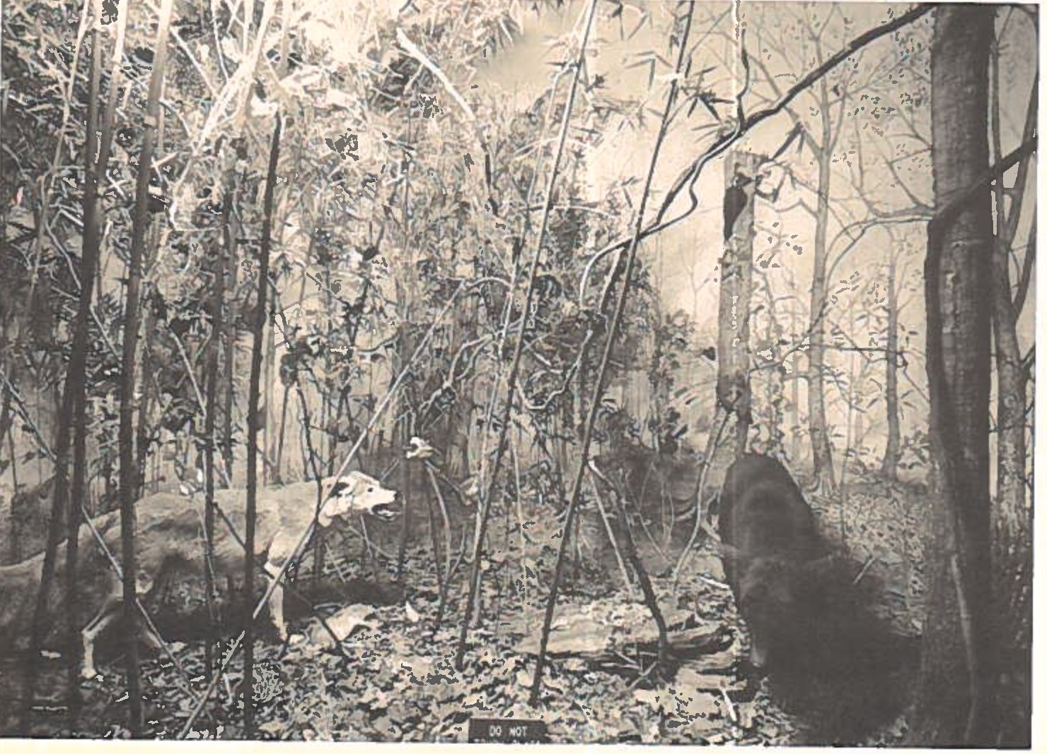

To furnish this display, Daigre and several assistants travelled to an area near Tallulah, Louisiana. They collected and photographed samples of leaves of all sizes. As many as 20,000 leaves might have to be 11made11 for a single exhibit. How complex and laborious a task this could be was described by an interviewer who quizzed Daigre during the construction phase:

Keep in mind that each leaf is covered with beeswax to get an impression which is molded in plaster, cast in plastic, cut out and painted
-- all by hand -- before being assembled on the homemade branch. To make the leaves more real­ istic, bug holes are made by burning holes in the plastic leaves with a hot wire. For blight spots, a toothbrush is used to splatter them with black paint. A plastic leaf held over a flame becomes a dead or wilted leaf.
Following the taxidermic and vegetative preparation came the development of a suitable "background." How did the Museum's curator of exhibits accomplish that crucial task? Once again, the interviewer:
Mr. Daigre paints the distant background first by projecting slides taken at the scene. The painting is done in layers, ranging from the most distant to the point where the two dimen­ sional and the three dimensional planes meet. These planes are fused by techniques such as rea1 branches growing out of painted trees. The 'sky', which is painted with an air brush, is curved for additional realism.
We get added insight into Daigre's skills when the time to build the base of the diorama arrives. To quote the interviewer again:
The "ground" is made to follow the natural terrain. A special mixture of paper machet [sic] and water is troweled on screen mesh over a wooden foundation. The top layer is actually top soi1 co11ected from the scene. Sma11 de­ ta i 1s are copied from the photographs and dili­ gently reproduced.

Daigre then placed the wildlife and the vegetation in the exhibit, taking care to maintain the natural perspec­ tive. Depending on what ti me of day he wanted it to be within the diorama, Daigre selected the appropriate light­ ing patterns. Once the interior was completed he then sealed his latest achievement behind a sheet of plate glass. When he stepped back a few paces to assay the "canebrake" diorama Daigre hoped (among other things} that
it would enjoy a life expectancy of 100 years. He believed that as natural scenes such as the "canebrake" were swept away by urban-industrial growth his habitat groups might be 11a11 that future genera ti ans have to te 11 them of the wild-
1i fe and plantlife that once lived in the vicinity." Whether or not the dioramas will survive to 2060 A. D., no one can possibly say. But in the twenty-five years since
Daigre glassed in his 11canebrake11 panorama the forces of "civilization" have cut such a wide swath through our natural environment that his concerns appear to have been vindicated.
When visitors glance downward from this diorama they see a commemorative tablet affixed to the wood ledge. It

is there because Lowery and a number of LSU people wanted to honor a young man of great promise: Jesse L. Webb, Jr., the second Mayor-President of their city. Born in Baton Rouge in 1923, Webb was an attorney who had very close ties to the University. After seven years as manager of the Parish's assessor's office he was elected Mayor in 1952 and took office on January 1, 1953. On Saturday, April 29, 1956, he and several other men died in a plane crash while on their ways to a national conference on metropolitan problems at Michigan State University. His untimely pass­ ing was an unexpected loss that shocked the Baton Rouge community. His friends at LSU approached Lowery and proposed that they fund the plaque that graces the diorama today. Lowery was pleased to accept their offer, saying of Webb: "He was an outdoors enthusiast, so it is most appropriate that this exhibit be dedicated to his memory." And so it was.

* * *

Rather than prolong the agonies of the early 1960's by rehearsing them in excruciating detail, we should be merci­ ful and simply refer to certain events that tell the story we11 enough. It must be said that they were years of both triumph and contradiction. There was a good deal to be ecstatic about, and much to bewail. To employ a contem­ porary vernacularism: first, the cheerful news.
Lowery was elected to membership on the International Ornithological Committee (1962) and received the "Out­ standing Conservationist of the Year" award from the Louisiana Outdoor Writers Association in March, 1963. In October, 1962, Robert Newman was made a Fellow (and Treasurer) of the American Ornithologists' Union. Museum field parties were active in Peru, Honduras, Costa Rica, and Mexico. Funds began to seep in from philanthropic, governmental, and institutional sources such as the National Science Foundation, University Council on Research, Louisiana Research Foundation, and the ever­ beneficent Mcllhenny family. Moribund since 1950, the "Occasional Papers" series was resuscitated by a $1,500 contribution from the LSU Foundation. Between October, 1961, and October, 1963, Lowery and his colleagues brought

in $2i,782.59 in "outside funds.11 If nothing else, that proved that the Museum could generate monies to support its research and educational efforts.
This positive pattern prevailed throughout the 1963-65 biennium. The annual May Count of visitors revealed that no less than 3,500 schoolchildren came to Foster Hall during that month. Sizeable, consistent grants from John
S. Mcllhenny and his relatives facilitated the purchase of important special collections and sustained several expe­ ditions to Central and South America. Five years after he started badgering the administration for an additional curatorial assistance, Lowery got his wish. In 1965, Dr. Douglas A. Rossman, who came to LSU in 1963 as an Assistant Professor of Zoology, was assigned one-quarter-time to the Museum as Assistant Curator in charge of lower vertebrates.
Lowery was particularly pleased with the progress of his research division, which was enjoying an "unprecedented expansion.11 Between 1961 and 1965 the total number of items catalogued rose dramatically. The bird collection escalated from 27,101 specimens to 45,096; mammals from 8,776 to 10,464; and reptiles, amphibians, and fishes from 6,329 to 10,393. By October, 1965, nearly 9,000 more

specimens remained uncatalogued "because of inadequate clerical assistance." Still, LSU's Museum was outranked in vertebrate holdings only by Harvard, Yale, Michigan, Berkeley, and Kansas. On a more personal plane, Lowery continued to reap honors and attend to his professorial duties. He was designated the first Fellow of the Louisiana Academy of Science in April, 1965, and wrapped up a five-year period (1960-65) during which he enabled twelve graduate students to receive advanced degrees.
On the debit side of the Museum Is ledger there were some disconcerting entries in this otherwise sanguine period. The most exasperating problem for Lowery was: retaining Eugene du Pont's interest in funding the Museum's expeditions in the face of LSU's obstinacy on the issue of space. It was awkward and embarrassing for Lowery to be accepting du Pont's support and yet be unable to produce tangible evidence of that gracious gesture in the form of public exhibits. No doubt Lowery promised du Pont that the family name would be mentioned in print, and perhaps on a tablet, somewhere among the new dioramas in Foster Hall's east wing. By the fall of 1963, Lowery's patience was fraying. He was a man who kept his word. Since 1959 he

had taken $67,500 from du Pont in good faith -- and all the New Zealand and Kenya materials were still in storage, limned in dust. Lowery planned to ask du Pont to finance a full-blown expedition to South America but he could not bring himself to seek closure, in view of the circum­ stances. Lowery told the administration that there was 11no solution to this problem short of the relocation of the Department of Fine Arts in order that the whole of Foster Hall may be turned over to the Museum." "How much longer," he asked, 11can the Museum be expected to endure in its cramped quarters?" University authorities must have decided that was a rhetorical question, since no response has been forthcoming to date.
By the fa11 of 1965, Lowery was very disillusioned. Nothing had changed. The University did surrender a base­ ment area formerly occupied by the LSU Bookstore but it could not be adapted for use in housing higher vertebrate collections. Lowery then shifted away from his 11all-or­ nothing-at-all11 platform to a 11we-will-settle-for-the­ second-floor11 proposal, thinking that LSU might bend a bit and help relieve the higher vertebrate glut. That adjust­ ment, he stated, would create adequate space for the

construction of "biological and geological exhibits.'' His request came to naught, even though he warned that "prob­ lems of immense magnitude" were in the offing if his suggestion was ignored. As for Mr. du Pont, Lowery reported tersely that LSU Is long-suffering benefactor had "elected to withhold further financial support until the first two exhibits are installed." Thus did the Museum lose one of its most generous patrons. And, we may deduce, so did LSU alienate the affections of a family that might have played a significant role in its future. For want of 21,000 square feet, a mother lode was lost. Was Lowery upset with this state of affairs? Indubitably. In his 1964-66 biennial report to his overseers he did not prepare a new section on "space needs." Noting that there was "a limit to the number of ways the same thing can be said," he merely quoted his 1962-64 remarks verbatim.
Before we shut the ledger and move on to the last diorama it is fitting to look back at the du Pont debacle and raise a few questions. First, whom shall we hold accountable for the loss of du Pont's support? The candidates who come to mind are the people who held the power at LSU between 1960 and 1965. The record shows that

they were not willing to move mountains to exploit the rare opportunity Lowery brought to the University. Their res­ pect for Lowery was enormous but, we may presume, not enormous enough to give him what he desperately needed: space. It might be more circumspect to say that LSU's appreciation for the long-term value of museumship was a1 ways underdeve1 oped. Lowery just happened to be the chief exponent of museumship on campus so he had to bear the brunt of his bosses' myopia.
Second, was Lowery himself in any way a culpable party
in the du Pont defection? Probably so. It is clear that he promised more than he could de1 i ver. By 1960, after twenty-five years of trying to draw blood from a stone (and extracting a few droplets now and them), Lowery might have guessed that LSU could not be intimidated into freeing space through the medium of dire predictions. Lowery truly believed that he could convince LSU to turn over the rest of Foster Hall based upon (a) the superb scholarly and grantsmanship performance of the research division, (b) unrelenting requests for assistance rooted in practical as well as theoretical justifications, {c) the involvement of a 11big-name11 benefactor, and (d) the increasing popularity

of the public exhibits -- not to mention the sheer logic of his position. Evidently Lowery found it difficult to internalize the cold, hard truth. And what might that have been? Insisting that the University dislodge an academic department (after fifteen years in Foster's east wing) to assuage the feelings of museologists was an unrealistic request to begin with, no matter how legitimate the cause. And, as reluctant as LSU authorities may have been to deny Lowery's supplications, they were not about to rob Art to pay a museum. That is bad politics. The Museum's ability to influence top-drawer decisions was never as great as Lowery thought it was (or should be). He was bound to lose any showdown he forced upon LSU when there were political ramifications at stake. And he lost the battle over Foster Hall. In the late 19801s, his museum still endures -- in its "cramped quarters.11

* * *

THE GREAT SOUTHWESTERN DESERT (1964)

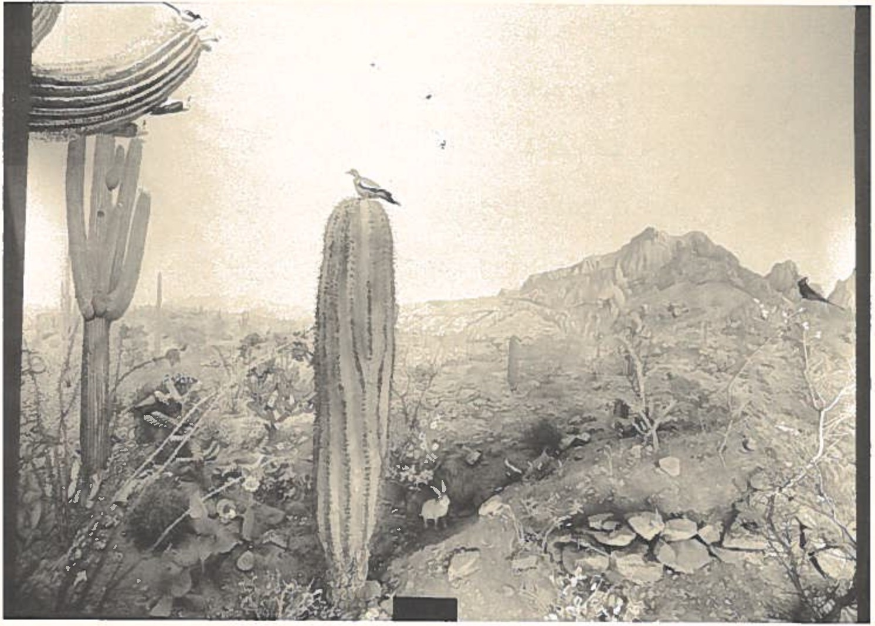

Space needs were not the only problems Lowery had to deal with in the early 19601s. In the spring of 1963 he almost lost the services of Ambrose Daigre. It came about when Dr. H. B. Wright, curator of State Exhibits in Shreveport, announced his retirement as of July 1, 1963. At sixty-eight Wright was at the end of a long and distin­ guished career. What strength he had left was being sapped by financial woes visited upon the State Exhibit Museum,

which was controlled by the Louisiana Department of Agri­ culture. In a pre-retirement press conference in Shreve­ port, Wright said he could no longer tolerate the constant struggle for funds and recornnended Daigre as his replace­ ment. "I consider him," Wright said, "the only top-notch man in the state to serve as curator. He is the only one with sufficient training and experience to handle the job ...." Daigre, who was in the room, was asked how he felt about replacing Wright. His reaction sounded as if he had already made up his mind to leave Baton Rouge. 11I love Shreveport," Daigre replied, "and I've maintained my home here in the hopes that I could return someday as curator." That was in April, 1963.
For awhile Daigre was in a quandary. Although there was no guarantee that Wright Is recommendation would carry the day with State officials, it gave him a pronounced edge over anyone else who might apply for the curatorship. Naturally, he was challenged by this opportunity. To be curator, he thought, would bring "progress and honor" to him after thirty years of laboring in the vineyards. Given the threadbare status of the State Exhibit Museum he would have to prove that he was as skilled an administrator as he

was a taxidermist. Connected as it was with diorama construction, his future at LSU was rather obscure. By 1963 it was obvious that the prospects for creating a whole new series of habitat groups in Foster Hall were dim. Why not put that phase of his life behind him and branch out? He had a house and a loving sister in- Shreveport. In a real sense it would be like "going home.11
On the other side of the argument there were strong centripal forces at work. The ninth diorama had to be completed. Lowery, Dean Cecil G. Taylor, and other admirers "expressed deep regrets II at the poss i bi 1i ty of Daigre's departure, which pleased him. They said they would not stand in the way of his attempt to improve his lot in life, butthey really did not want to see him leave LSU. His wife Florence was we11 situated as a teacher in the local public schools and not terribly pleased over the prospect of leaving Baton Rouge. And Daigre was barely into a private coll'VTlercial venture that he would have to abort. Shortly before the Shreveport opportunity devel­ oped, he es tab1i shed the American Wildlife Studios, Inc. at 8647 Highland Road, where he intended to practice, and train others in, the taxidermic sciences.

Daigre decided to forsake the curatorship and continue at LSU. On Mother's Day, 1963 (May 12), he wrote to his sister Helen in Shreveport, saying:
I have turned in an official letter to the Dean [Taylor] and George [Lowery] expressing my de­ sire to remain at L. S.U. The Dean wrote me a nice letter, George and Bob [Newman] seem pleased at my decision and of course the staff is greatly pleased. All the teachers at Florence's school and a number of the professors have expressed the opinion that I made a very wise decision.
Had Daigre left LSU there would be no "Southwestern Desert" diorama in Foster Hall. As soon as he settled the issue of staying or going he got busy on the ninth exhibit. On May 15, 1963, Daigre and Lowery's father set off for the Great Southwestern Desert. They stayed at the Boyce Thompson Southwestern Arboretum near Superior, Arizona, for two weeks collecting, touring, and taking pictures of the grandeur that lay before them at the foot of the Super­ stition Mountains. 11Grandad11 Lowery, who was in his late seventies, seemed none the worse for the wear when he and Daigre returned in June.
The new diorama was opened to the public on June 18, 1964. There was more to see in the exhibit than met the eye at first glance. Daigre had carefully placed plant

forms, lizards, birds, and a snake within his recreation of "a hot, arid corner of North American Scrub Desert." The epicenter of the display, a giant cactus, tended to draw attention away from its subtler aspects. Over the years the saguaro cactus has been an ideal subject for journal­ ists and photographers. As recently as August 31, 1986, it was featured in the Baton Rouge Sunday Advocate as a promi­ nent adjunct to a piece by C. Richard Cotton, "LSU Museum of Natural Science is 50 Years Old." We shall let another
reporter from an earlier time {1964) tell us about Daigre's sleight-of-hand:
In creating the exhibit, Daigre was confronted with a very sticky job, literally. To produce l ife-1i ke replicas of the giant saguaro and the other cacti, [Daigre] removed all the thorns and stickers from the real cactus and placed them in clay in the exact location and arrange­ ment in which they grew on the ori gi na l. Daigre's next step was to make a plaster cast of the remaining fleshy part of the cactus, then recast the form in a combination of wax and synthetic rubber-like material. He ob­ tained the true color of the plant by inserting colored pigment into the melted wax.
With the completion of this exhibit, the era of the diorama in the Museum's history came to a close. After twelve years of unflagging· dedication Daigre had made his unique contribution to Lowery's "dream plan." All the

plant and animal materials necessary to the preparation of several more exhibits were scattered throughout the cavit­ ies of Foster Hall, but Daigre was pretty sure they would not see the light of day. He did a mini-diorama of an 11African Waterhole11 for display in Pleasant Hall in 1968 and remained with the Museum until his retirement. He took with him many wonderful memories and left us with the magnificent products of his lively mind. A remark made by Dean Taylor in 1963 when he thought Daigre might move to Shreveport seems a proper salutation as we move on to the next stage of the Museum's story. 11Mr. Daigre,11 Taylor said, 11even though you leave Louisiana State University, there will always be a part of you that will remain with
US• II

PART THREE: TOWARD A NEW MILLENIUM

The world is changing so rapidly in so many ways...that it is hard for too many of us to orient ourselves, hard not to find the world a terrifying and almost indistinguishable blur. We can use the museum to help us in the task of bringing coherence out of this wilderness. Grasping the nature and the direction of chan­ ges, we can control change, realize our realiz­ able needs and aspirations, and take charge of our future.
Samuel Cauman, The Living Museum {1958)

PART THREE: TOWARD A NEW MILLENIUM

MURPHY J. FOSTER HALL

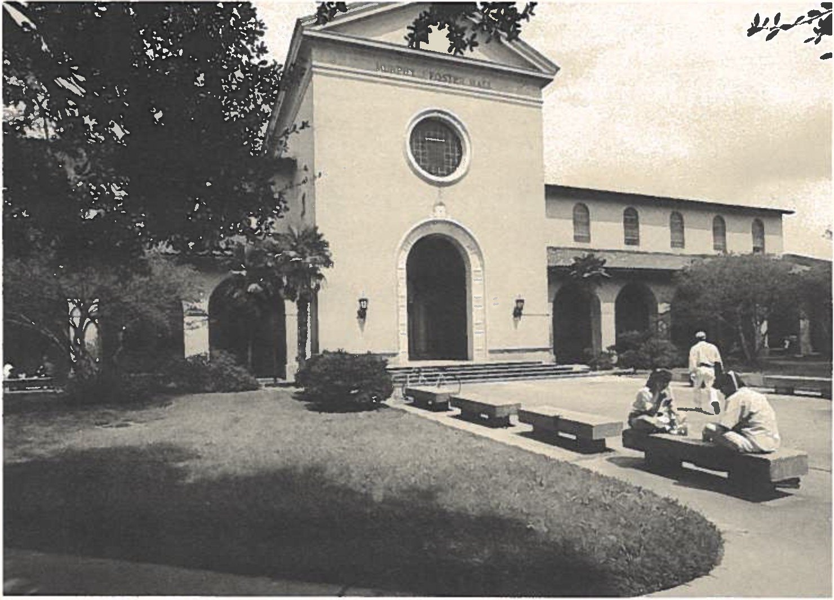

Between 1987 and 1999 it is likely that Americans will give vent to one of their favorite compulsions: ex post facto cri ti ci sm, sometimes referred to as "Monday-morning quarterbacking." This time it will be done on a grand scale. We will be inundated with unsolicited assessments
of humankind's performance since 1900. Social and

political scientists (and "media analysts") will be in the vanguard of the judges and prognosticators who will tell us where we have been and where we appear to be headed. The ten decades of the Twentieth Century will probably receive a mixed report card. They have been riddled with military conflict, political corruption, physical abuse, and moral degradation. Certainly someone will be able to prove that it was the most violent century in recorded history. Con­ versely, these one hundred years are replete with sterling examples of the human spirit in its finest form. Important defeats have been levied upon the forces of pedantry and cruelty. Technology has, in most instances, enhanced the quality of life. Intellectual fascism has been under constant siege by the universal conscience. Faith, hope, and charity still block the ascendancy of total despair. We cannot presume to divine at what stage LSU and its Museum of Natural Science will be when the Museum's centennial comes in 2036 A. D. All we are certain of is what occurred during its first fifty years. From that we may infer what might happen, but it is safer to depend on what we know. We know that Ambrose Daigre retired from LSU effective September 1, 1972; that George Lowery worked in

Foster Hall until the day of his death; and that the Museum survives. Those are the stories that we can complete with confidence -- and then leave the future to our successors. When Daigre realized that there would be no new dioramas in Foster Hall he sought professional opportuni­ ties elsewhere. In 1963, Mrs. Ruth B. Zigler, widow of Jennings, Louisiana industrialist Fred B. Zigler, decided to memorialize her late husband's contributions to the community by founding a museum. As the public brochure tells us, 11She established a museum trust and donated the property, which had been the Zigler family home since 1908.11 Two wings were added to the 11charming colonial styled structure11 on Clara Street in Jennings. The museum was opened to the public in 1970. Ambrose Daigre was very much present in the east wing. Between 1966 and 1972, representing American Wildlife Studios, he prepared nine
dioramas for the Zigler group: 11Some Louisiana Ducks in Spring11 (1966), 11A Snowy Egret Nesting Colony11 (1967), 11Some Well-Known Louisiana Geese11 (1967), 11Mallard and Pin-Tails in Take-Off Flight11 (1969), 11Fulvous Tree Ducks11 (1969}, 11Interesting Inhabitants of the Coastal Marshes11

(1969), "Roseate Spoonbills" (1969), "Upland Game" (1972), and "A Bird-Feeding Station" (1972).8
The Zigler dioramas revealed that Daigre, then in his sixties, had lost none of his magic touch. He completed the same number of habitat groups for Ziegler in six years as he had for LSU in nine, and he was paid an average of
$3,000 per diorama on delivery, and in a very business- like manner, by the Zigler represe tatives. It was a refreshing change from his hand-to-mouth experiences at LSU and he reveled in it. Along the way Daigre did a diorama called "The Courtship of the Wild Turkey" (1971) for placement in the State Capitol Building. It was financed by the Louisiana Wildlife and Fisheries Commission.
After Daigre retired in 1972 he remained active but, insofar as recognition from LSU was concerned, he went into a veritable eclipse until 1985. The newly formed LSU-MNS

- For reasons unknown to this writer, in the spring of 1985 two of the Zigler-Daigre dioramas were moved from the museum to the Jefferson Davis Parish Courthouse and seven were exported for display at the Jefferson Davis Parish Fairgrounds. It is reported that several of the dioramas will be returned to the Zigler Museum, but details of these transferals were not available as of September, 1986.

Patrons Association (1984) "discovered" Daigre and invited him to discuss how he created the Foster Hall dioramas at its July 16, 1985, meeting. His reappearance was a resounding comeback. Museum veterans and novices alike came to the realization that Daigre had "played a pivotal role in the success of the internationally acclaimed facility," a role for which he received precious little reward. These revelations motivated the Patrons Associa­ tion to sponsor a semi-centennial monograph on the history of the public exhibits and arrange for a public demonstra­ tion of respect. On January 31, 1986, Daigre was presented with the Patrons Association first certificate of honorary membership by President C. Fenton Rutledge. Rutledge spoke for many persons when he said:
It is fitting that our first honorary member­ ship be bestowed on Mr. Daigre, whose knowledge and artistry have brought pleasure to countless people during the past 30 years and are a legacy to countless others in the future.
Three days later the Baton Rouge Morning Advocate published an editorial entitled "A Debt of Gratitude" devoted in entirety to Daigre. It began by saying that,

"Anyone who over the years has taken in the eye-catching dioramas at the LSU Museum of Natural Science ... owes a debt of gratitude to P. Ambrose Daigre who painstakingly constructed those striking displays." And it concluded, "We, who will notas will P. Ambrose Daigre1s displays last for 100 years, express our appreciation to him and those at LSU who assisted him over the decades." If it is true, as Alma Wittlin observed in 1970, that "Museums are not ends in themselves; they are means in the service of man and his cultural evolution," then Daigre, in his own special way, was a superior servant-teacher. His II lessons II are pre­ served behind glass at Foster Hall, and his pupils come by the thousands every month to learn from the master.
It is appropriate now to address a minor issue, viz., how Daigre and Lowery "got along" between 1952 and 1972. The adjective "minor" is employed as a way of suggesting that the quality of their bequest far outweighs any problems they had with each other in their capacities as shareholders in a common project. The existence of the public exhibits lends perspective to any observations we might make about their personal interactions. Conflicts

may be intriguing but they are no longer significant. However, it serves neither Daigre nor Lowery well to lapse into a heroic interpretation of their years together. They were men, not demigods. Therefore, as one person who knew them put it, their relationship had its 11ups and downs.11
Each man was single-minded about his particular task, inflexible at times, and disposed to favor his own opinions about how things ought to be done. Each felt he was doing a good deal of adjusting to the other's idiosyncrasies. Both men clung tenaciously to their respective pieces of the 11dream plan.11 Their views on the mission of the Museum did not mesh perfectly, which, given the disparities in their backgrounds and assign­ ments, should not amaze us. Lowery was an internation­ ally recognized scholar-scientist whose administrative and professional duties were enormous. Daigre was a highly skilled, professional craftsman whose duties were expressly restricted to the preparation of educational exhibits. Ideologically and stylistically they approached their tasks from discrepant angles. There were bound to be

some disagreements in the midst of twenty harmonious years. People clash when they are under stress, and Lowery and Daigre were in very close contact during a period in LSU's history when the temperamental traffic was extremely heavy. For the Museum, it was always rush hour (or so it seemed). What matters is that they managed to reconcile their differences in the name of a higher aspiration -- the realization of their "dream plan" for museumship at LSU. They needed each other, and they knew it. The i ncontro­ verti ble evidence of their successful fusion of talents
stands before us in Foster Hall.

* * *

In 1973, the Museum was visited by an American Association of the Museums accreditation team. It made a "basically favorable recommendation" to the AAM's Accreditation Commission in Washington, D. C., but the Commission withheld final accreditation "pending rectifica­ tion of...serious deficiencies", namely:

inadequate security to protect against fire, theft, and vandalism; (2) lack of space and adequate staff that prevents the museum from realizing its full potential; and (3) the failure of the organizational chart of the University to show where the museum fits into the lines of authority, or, in other words, to whom in the administrative setup of the Univer­ sity the Director of the museum is responsible.
Lowery was understandably perturbed, on two counts. First, the "deficiencies" were the result of years of benign neglect by successive administrations. The Museum was in no position to correct problems over which it had no control. Security, space, and organizational patterns were LSU's responsibility. No one could claim that Lowery had been silent on these issues, although he was not particu­ larly dissatisfied with the Museum's position under the Dean of the College of Arts and Sciences. When he forwarded a copy of the Accreditation Commission's findings to Chancellor Cecil G. Taylor on December 4, 1973, he asked for a meeting to discuss the issues. Taylor suggested he talk with several Vice-Chancellors and added an ominous, but familiar, last line to his December 14 memo: "The possibilities of providing additional space and increasing museum personnel in the very near future do not seem to me

promising at this time."
Lowery was distressed also because a tactic employed by the 1973 visiting team imploded. Apparently, the team members thought they could help the Museum by stressing its deficiencies, a maneuver that works, sometimes. They believed that their report might aid Lowery in making his case with LSU's higher-ups. In this instance the tactic produced a contrary result. As Lowery told one member of the team: "Unfortunately, your report backfired by magni­ fying some of our shortcomings in the eyes of the Accreditation Committee to such an extent that it withheld accreditation." As one might expect, Lowery's ego was bruised by the AAM Is rejection. He had invested nearly forty years in the Museum, living through the trials and torments of Job just to keep it from "going under." A slap at the Museum was a slap at him, therefore. It did not soothe his ruffled feathers to know the AAM had awarded accreditation to what he considered to be lesser institu­ tions such as the Stovall Museum at the University of Oklahoma and -- unkindest cut of all the Louisiana Arts and Science Center in Baton Rouge. Lowery did not calm

down for a year, if ever. On November 8, 1974, he told an old friend that he was disinclined to "incur the additional expense" of bringing an accreditation team back to LSU to re-check the original 11deficiencies,11 and was seriously thinking about "dropping our membership" in the AAM. The team did not return, the Museum's space needs were not met by LSU, and accreditation was never given -- then, or since.
The denial of accreditation was a severe blow to
Lowery. The death of his father in 1974 was even harder to digest. He and George, Sr. were very close, especially so after Lowery's mother died in 1943. 11Grandad11 Lowery lived
- with his son and his family for thirty-one years, joined in on as many of his son's projects as he could, and usually charmed anyone who came within his life space. His passing at eighty-nine was a terrible loss to Lowery and its effect upon him was noticeable. Still, he refused to reduce his self-imposed schedule. He minimized his ailments and drove himself to put in as many hours at Foster Hall as his body would tolerate. And, as if to say that he was not yet "over the hill,11 Lowery published his The Mammals of Louis­ iana and Its Adjacent Waters in May, 1974. It won him his

second Louisiana Literary Award. Five students who studied under Lowery received their advanced degrees in 1974. One of the five was John P. O'Neill, Ph.D., who was to play an important part in the next phase of the Museum's storm­ tossed history.
On Wednesday, January 18, 1978, Lowery went to his office at the Museum as usual. He was feeling reasonably well and showed no visible signs of physical discomfort. At 5:00 A.M. the following morning he died. The immediate cause of death was given as a heart attack. He was interred in Roselawn Memorial Park on North Street in Baton Rouge on Friday, January 20. He rests there in plot 133-G beside his beloved wife, Jean, who joined him in death on February 12, 1983. On January 23, 1978, the George H. Lowery, Jr. Memoria1 Fund For Research and Pub1ication in Vertebrate Zoology was established within the LSU Founda­ tion with the understanding that the monies accrued would not be used to pay the salaries and operational expenses ordinarily covered by University appropriations. As of the fall of 1986 the Memorial Fund balance was approaching
$37,000. On February 16, 1978, Oliver P. Stockwell, chairman of the LSU Board of Supervisors, wrote a letter of

condolence to Jean Lowery in which he said that, "Dr. Lowery's reputation...will continue to influence the lives of his associates and students and wi11 never be forgotten. 11 Be1ow, we wi11 return to that thought and attempt to fashion a summation of that inheritance.
The day after Lowery died John O'Neill was made Acting Director of the Museum. On July 1, 1978, he was appointed Director, a post he held until July, 1982. He was succeeded by Dr. J. M. "Mike" Fitzsimons (1982-84), who turned over the directorship to Dr. Douglas A. Rossman in 1984. These men presided over the Museum during seven of its most tremulous years. Between 1978 and 1985 the Museum bobbed up and down precariously on the choppy waters of University policies and politics. Lowery was no longer present in the flesh, which created an ineffable void, but his colleagues were well schooled in the art of self­ defense. They protected the Museum against incursions, invigorated the activities of the research division, pressed the University for both staff and space, and went on the offensive when their adversaries were napping. In brief, they carried the Lowery tradition of stubborn advocacy forward without missing a step. When the smoke

cleared in 1985 conditions were vastly better in the arenas of research, personnel, and budget (which is now at
$325,000), but very much the same in zones such as space for public exhibits and funds for non-domestic expeditions.
The advances made in the wake of Lowery's passing were not achieved passively. O'Neill, Fitzsimons, Rossman, and their colleagues reacted aggressively to external encroach­ ments, parachuted into campus squabbles that impinged upon the Museum's well-being, acted decisively when called upon for opinions by the administration, and prepared incisive proposals and surveys in support of the Museum Is needs. They stoutly resisted an attempted coup in 1979-80 that would have necessitated a move from Foster Hall to an annex adjacent to the Life Sciences Building (and have required that all the public exhibits be torn down and then recon­ structed, at a cost of $250,000 at a minimum). They objected strenuously in 1980 to an LSU plan to take over the second floor of Foster Hall for conversion into admini­ strative offices, with "no provision made for the addition of any of the educational or public exhibits." In 1981, they sought and received approval for the transfer of the Museum from Arts and Sciences to the office of the

docents was organized and the Museum reopened its doors on Saturdays under their aegis.
Eight years after the calamitous accreditation controversy the AAM wafted back into the Museum's sphere of operations in the form of Dr. Craig C. Black. President of the AAM and Director of the Carnegie Museum of Natural History, Black visited LSU on April 22-23, 1981, to evaluate the status of museumship on campus. He was very direct in his remarks to the administration, saying that LSU was delinquent in "the process of museum formation and development." He felt that "no conscious commitment to the museum program or evaluation of its role in serving the University's mission ever seeJTIS to have been made 11
Black urged LSU to make up its mind about the role and fate of its museums [Anglo-American Art, Geoscience, and Natural Science], give them "clear and strong support," and centralize its museums under one roof. The centralization notion was not new. On January 26, 1977, a University Museums Committee met in Lowery's office to initiate discussions on the feasibility of "unifying the several museums under one general administration." Nothing came of it then, but Black's report rekindled interest in the

Vice-Chancellor for Research, which became effective on July 1, 1982. The following year they (and H. Parrot Bacot, executive director of the LSU Museum Complex) reminded the authorities that "Two decades and a half-dozen major reports have not afforded the Museum any additiona1 space." As Bacot viewed it, space deficiencies were "far worse than those confronting the accreditation team" in 1973. Every white paper sent forward by the Museum in the early 19801s hammered away on that theme.
Reinforcements were on the way. On August 12, 1980, a 11Provisi ona1 Counci 1 in Support of the Museum of Natura1 Science" held its first meeting. From that body emerged the Board of Fellows of the Museum {May, 1981), a volunteer panel dedicated to estab1 ishing a "friends" organization that could render moral and material backing to the Museum staff's objectives. In September, 1984, the LSU-MNS Patrons Association held its first meeting in Foster Hall. Within four months 120 people had become members of the Association. By the summer of 1986 the number had risen to
200. In April, 1985, one of Lowery's unfulfilled dreams became a reality. Out of the Association a cadre of

concept among those in higher circles. In 1982, as an element in Chancellor James H. Wharton's "Quest For Quality" movement, the idea of an LSU Museum Complex was brought forth. The fo 11owing quotation from the pamphlet circulated throughout the LSU community sounded very promising:
The reputation that LSU already enjoys in acad­ emic circles has been built in no small part on the collections and research work of the Mus­ eums ... At present, a11 of the campus Museums are housed in outmoded buildings which were originally designed for other purposes. Spa­ tial limitations in each facility hamper both the display of collections and access to ob­ jects placed in storage. This lack of space has forced the Museums to turn down important donations and has discouraged other potential donations ... If the University is to attain its present goal of entering the august number of the foremost twenty or thirty universities in America, the campus Museum must be provided proper quarters and endowments.
These words, without much variation, might have been taken from any one of Lowery's reports to the administra­ tors he worked for between 1958 and 1978. They echo his sentiments exactly. They communicate a sensitivity that one has a right to expect of the leadership of Louisiana's

flagship University.9 And yet, to date, no ground has been broken. Nearly five years after its announcement the Mus um Complex is still a dream, another dream that Lowery's legatees endorse with enthusiasm but do not await breathlessly. On September 12, 1986, the LSU Board of Supervisors approved a capital outlay program that included a $156,477,369 request for thirty-four "renovation and construction projects" on the Baton Rouge campus during the period 1987-92. The Museum Complex was not on LSU's "wish list.11
* * *

- The Comp1ex was to be composed of four inter-connected buildings located on a special site near University Lake, making it easily accessible to tourists, students, faculty, staff, and visiting scholars. In 1982 the estimated cost of constructing and furnishing such a facility was approximately $30,000,000, a projection that would have to be revised upwards with each passing year unless the original project were amended to a more modest proportion. It is interesting to note that the 1982 brochure advertising the Complex stated, "Without new facilities the LSU Museum of Natural Science cannot reach its full potential...as a preeminent center of teaching and research in the world.11

Earlier in this text we posited that "the evolution of LSU's Museum of Natural Science and the life of George Lowery are inseparable aspects of the same story." There can be little doubt about that now. We can say unequiv­ ocally that the Museum exists because Lowery willed it into existence fifty years ago and refused to let it die before he did. No one disputes the contention that the Museum "was his life." His "dream plan" for museumship at LSU propelled, animated, and consumed him all at once. Blessed with a stereophonic imagination, he envisioned a Museum that both educated the masses and edified the scientific community. His magisterial view of what a Museum should be was not always shared or understood by his professorial and administrative peers, but that is usually the sentence awarded to persons who commit the high crime of being ahead of their times. When Lowery erred it was on the side of being zealous on behalf of a cause that less fertile minds could not grasp. When he suffered setbacks it was often due to his lack of guile. In his relations with others he found it impossible to be deceitful, cunning, or cynical
a commendable deportment that, unfortunately, rendered him
vulnerable to parties with less honorable (or different)

standards.
How sha11 we characterize Lowery Is 111egacy11 nearly nine years after his death? Those who knew him have no difficulty answering that question. Lowery was the father of LSU's Museum of Natural Science. He gave it visibility, credibility, and legitimacy at LSU and beyond by virtue of his credentials, his standing in the professional world, and his sense of personal integrity. He established high standards for graduate study. He employed talented, dedicated people such as Ambrose Daigre to assist in the realization of the Museum's goals. He was the moving force behind the development of the research collections and the South American fie 1d programs. He was the originator of the educational theory that lay behind the creation of public exhibits in Foster Hall. And he showed us how to fight for the Museum Is needs -- by the Queens berry Ru1es. In short, Lowery established patterns of thought and behavior that his disciples find themselves practicing to this very day throughout the international scientific community.
Finally, and perhaps most important of all, Lowery was the source of the aura of 11fami ly11 that pervades Museum
164

operations in the late 1980's and gives Foster Hall its special esprit and flavor. By personal example rather than by any conscious plan, Lowery cultivated within his colleagues, students, and staff the feeling of "belonging" to the Museum, to LSU, and to the world of scholarship that envelop Foster Hall even now. By association, if not in fact, we are all beneficiaries of George Lowery. In 1951 he to1d one of his scores of friends and admirers: "One thing is that you can't live forever and that one must be a good [Christian] to the extent of thinking 'what is to be wi11 be'."
What was, was wonderful. And he taught us how, within our human limitations, to shape what should be.

165

ABOUT THE AUTHOR

Peter A. Soderbergh was born in Brooklyn, New York, in 1928. He received his degrees from Amherst College, Harvard University, and The University of Texas in Austin. During the Korean War he served in combat as a U.S. Marine officer. Prior to coming to LSU he held faculty and admin­ istrative positions in the public schools and at the universities of Texas, Pittsburgh, and Vir­ ginia. Dr. Soderbergh was Dean of LSU's College of Education from 1976 to 1981. Currently he is Di rector of the Office of Academic Deve1opment, Chairman of the University Commission on General Education, and Professor of Education. He has published eighty articles and five books on a wide variety of topics such as children's litera­ ture, cinema, special education, biography, and popular music. He is the father of six children and the grandfather of two boys. Dr. Soderbergh first involved himself in the affairs of the Museum in 1980 and was instrumental in the forma­ tion of the LSU-MNS Patrons Association. He is chairman of the Museum's Board of Fellows.

167

Persons interested in joining the Patrons Association of the LSU-MNS or contributing to the George H. Lowery, Jr., Memorial Fund may inquire about either opportunity at the following address: Louisiana State Univer­ sity Museum of Natural Science, 119 Foster Hall, LSU, Baton Rouge, Louisiana 70803. Telephone inquiries are welcome at (504) 388-2855.

Additional autographed copies of this volume may be procured by writing or telephoning the Museum.

PATRONS
L8u 1 1¥1ltlial
Museum al Natural Science

